VIVEKANAND EDUCATION SOCIETY’S INSTITUTE OF TECHNOLOGY

(An Autonomous Institute Affiliated to University of Mumbai)
Department of Computer Engineering



Project Report on

CredMill - An AI Credit Risk Assessor

In partial fulfilment of the Fourth Year, Bachelor of Engineering (B.E.) Degree in Computer Engineering at the University of Mumbai Academic Year 2025 - 26

By

Gaurav Gupta (D17C-26), Suryanarayan Panigrahy (D17C-47), Harsh Patil (D17C-50),
Hemant Satam (D17C-56)

Project Mentor

Dr. (Mrs.) Gresha Bhatia
Deputy HOD, Department of Computer Engineering

(A.Y. 2025 - 26)

VIVEKANAND EDUCATION SOCIETY’S INSTITUTE OF TECHNOLOGY

(An Autonomous Institute Affiliated to University of Mumbai)
Department of Computer Engineering


Certificate
This is to certify that Gaurav Gupta (D17C - 26), Suryanarayan Panigrahy (D17C - 47), Harsh Patil (D17C - 50), & Hemant Satam (D17C - 56) of Fourth Year Computer Engineering studying under the University of Mumbai have satisfactorily completed the project on “Credmill
- An AI Credit Risk Assessor” as a part of their coursework of PROJECT - II for Semester - VIII under the guidance of their mentor Dr. (Mrs.) Gresha Bhatia in the year 2025 - 26.

This project report entitled “Credmill - An AI Credit Risk Assessor” by Gaurav Gupta, Suryanarayan Panigrahy, Harsh Patil & Hemant Satam is approved for the degree of Bachelor of Engineering in Computer Engineering.

Programme Outcomes | Grade
PO1, PO2, PO3, PO4, PO5, PO6, PO7, PO8, PO9, PO10, PO11, PO12
PSO1 & PSO2

Date: 27th April, 2026
Project Guide:Dr. (Mrs.) Gresha Bhatia

Project Report Approval For
B. E (Computer Engineering)

This project report entitled “ Credmill: An AI Credit Risk Assessor ” by Gaurav Gupta (D17C - 26), Suryanarayan Panigrahy (D17C - 47), Harsh Patil (D17C - 50), & Hemant Satam (D17C - 56) is approved for the degree of Bachelor of Engineering in Computer Engineering.

Examiners

1. ………………………………
(Internal Examiner name & sign)

2. ………………………………
(External Examiner name & sign)

3. ………………………………
(Head of Department)

4. ………………………………
(Principal)

Date: 27th April, 2026
Place: Chembur, Mumbai

Declaration

We declare that this written submission represents our ideas in our own words and where others' ideas or words have been included, we have adequately cited and referenced the original sources. We also declare that we have adhered to all principles of academic honesty and integrity and have not misrepresented or fabricated or falsified any idea/data/fact/source in our submission. We understand that any violation of the above will be cause for disciplinary action by the Institute and can also evoke penal action from the sources which have thus not been properly cited or from whom proper permission has not been taken when needed.

(Gaurav Gupta - D17C / 26) (Suryanarayan Panigrahy - D17C / 47)

(Harsh Patil - D17C / 50) (Hemant Satam - D17C / 56)

Date: 27th April, 2026

Acknowledgement

We are thankful to our college Vivekanand Education Society’s Institute of Technology for considering our project and extending help at all stages needed during our work of collecting information regarding the project.
It gives us immense pleasure to express our deep and sincere gratitude to the Head of the Computer Department Dr. (Mrs.) Gresha Bhatia (Project Guide) for her kind help and valuable advice during the development of project synopsis and for her guidance and suggestions.
We are deeply indebted to our Principal Dr. (Mrs.) J.M. Nair, for giving us this valuable opportunity to do this project.
We express our hearty thanks to them for their assistance without which it would have been difficult to finish this project synopsis and project review successfully.
We convey our deep sense of gratitude to all teaching and non-teaching staff for their constant encouragement, support and selfless help throughout the project work. It is a great pleasure to acknowledge the help and suggestion, which we received from the Department of Computer Engineering.

We wish to express our profound thanks to all those who helped us in gathering information about the project. Our families too have provided moral support and encouragement several times.

COURSE OUTCOMES FOR B.E. PROJECT

Learners will be able to,

Course Outcome | Description of the Course Outcome
CO1 | Able to apply the relevant engineering concepts, knowledge and skills towards the project.
CO2 | Able to identify, formulate and interpret the various relevant research papers and to determine the problem.
CO3 | Able to apply the engineering concepts towards designing solutions for the problem.
CO4 | Able to interpret the data and datasets to be utilized.
CO5 | Able to create, select and apply appropriate technologies, techniques, resources and tools for the project.
CO6 | Able to apply ethical, professional policies and principles towards societal, environmental, safety and cultural benefit.
CO7 | Able to function effectively as an individual, and as a member of a team, allocating roles with clear lines of responsibility and accountability.
CO8 | Able to write effective reports, design documents and make effective presentations.
CO9 | Able to apply engineering and management principles to the project as a team member.
CO10 | Able to apply the project domain knowledge to sharpen one’s competency.
CO11 | Able to develop a professional, presentational, balanced and structured approach towards project development.
CO12 | Able to adopt skills, languages, environment and platforms for creating innovative solutions for the project.

Index

Chapter No. | Title | Page No.
 | Abstract
Chapter 1 | Introduction | 1
1.1 | Introduction | 1
1.2 | Motivation | 1
1.3 | Problem Definition | 2
1.4 | Existing Systems | 3
1.5 | Lacuna of the existing systems | 3
1.6 | Relevance of the Project | 3
Chapter 2 | Literature Survey | 5
A | Brief Overview of Literature Survey | 5
B | Related Works | 5
2.1 | Research Papers Referred | 6
2.2 | Patent Search | 9
2.3 | Inference drawn | 10
2.4 | Comparison with the existing system | 10
Chapter 3 | Requirement Gathering for the Proposed System | 11
3.1 | Introduction to requirement gathering | 11
3.2 | Functional Requirements | 11
3.3 | Non-Functional Requirements | 12
3.4 | Hardware, Software, Technology and Tools utilized | 13
3.5 | Constraints | 15
Chapter 4 | Proposed Design | 17

4.1 | Block diagram of the system | 17
4.2 | Modular design of the system | 18
4.3 | Detailed Design | 20
4.4 | Project Scheduling & Tracking (Gantt Chart) | 21
Chapter 5 | Implementation of the Proposed System | 23
5.1 | Methodology employed for development | 23
5.2 | Algorithms and flowcharts for respective modules | 23
5.3 | Dataset source and utilization | 25
Chapter 6 | Testing of the Proposed System | 26
6.1 | Introduction to testing | 26
6.2 | Types of tests considered | 26
6.3 | Test case scenarios | 27
6.4 | Inference from test cases | 29
Chapter 7 | Results and Discussion | 30
7.1 | Screenshots of UI modules | 30
7.2 | Performance evaluation measures | 35
7.3 | Input parameters / features | 35
7.4 | Graphical and statistical output | 36
7.5 | Comparison with existing systems | 37
7.6 | Inference drawn | 38
Chapter 8 | Conclusion | 39
8.1 | Limitations | 39
8.2 | 8.2 Conclusion | 39
8.3 | 8.3 Future Scope | 40
Chapter 9 | References | 41

Chapter 10 | Appendix | 42
11.1 | Paper I & II Details  - Paper published  - Certificate of publication  - Plagiarism report  - Project review sheet | 42

Abstract

This project proposes CredMill, a resource-efficient, explainable, and fair AI-driven credit risk assessment system designed for small-to-medium-scale operational environments. Traditional manual credit evaluations are slow, prone to human inconsistency, and often fail to capture complex, nonlinear patterns in borrower data. While AI-based solutions have demonstrated improvements in predictive accuracy, they frequently function as opaque “black boxes,” demand costly computational resources or proprietary APIs, and overlook the need for fairness auditing and bias mitigation. CredMill addresses these limitations by integrating lightweight yet high-performing machine learning models—particularly tree-based ensemble methods—with interpretability frameworks such as SHAP and LIME to ensure transparency at both global and individual decision levels. The system combines traditional credit data with selected alternative data sources, allowing it to model a broader view of borrower creditworthiness without excessive computational overhead. By embedding fairness metrics and mitigation strategies into the workflow, CredMill ensures compliance with ethical and regulatory standards while maintaining strong predictive capability. The final design delivers a practical, low-cost prototype capable of running on modest hardware or free cloud platforms, offering lenders a transparent, adaptable, and equitable tool for credit decision-making.

Chapter 1: Introduction

Introduction
Credit risk assessment lies at the core of every lending operation, as it directly influences decisions such as loan approval, credit limit allocation, and interest rate determination. The primary objective of credit risk assessment is to estimate the likelihood of a borrower defaulting on a loan or financial obligation. Traditionally, banks and financial institutions have relied on manual assessments or predefined scoring models such as credit bureau scores. While these approaches have been effective to an extent, they are often time-consuming, subjective, and limited in their ability to handle large-scale and heterogeneous data.
With the rapid advancement of Artificial Intelligence (AI) and Machine Learning (ML), financial institutions have started leveraging data-driven approaches for automating and refining the credit evaluation process. These intelligent systems can identify complex, nonlinear relationships between financial variables, behavioral patterns, and repayment histories, leading to more accurate risk prediction. However, many AI-driven systems operate as “black boxes”, offering little to no transparency in how decisions are made. This lack of interpretability poses significant challenges for compliance, trust, and ethical deployment—particularly in regulated industries like finance.
CredMill aims to bridge this gap by developing an explainable, fair, and computationally efficient credit risk assessment system. The project focuses on providing interpretable decision-making through explainable AI (XAI) methods while ensuring that the model’s predictions remain equitable and resource-friendly. By doing so, it supports responsible and transparent AI usage in financial decision-making environments.

Motivation
In the modern financial ecosystem, digital lending and AI-based credit scoring have become increasingly prevalent. However, small and medium financial institutions, especially in developing economies, often face barriers to adopting such technologies. Many of the existing AI models demand high-end infrastructure, depend on expensive APIs or cloud services, and fail to incorporate explainability and fairness—two pillars essential for building trust among stakeholders and regulators.

Moreover, as AI systems learn from historical data, they are susceptible to bias and discrimination, especially when the underlying datasets reflect social or economic inequalities. Such biased systems may unintentionally disadvantage specific demographic groups, raising ethical and legal concerns.
The motivation behind CredMill is therefore twofold:
    - To democratize access to AI-powered credit scoring tools that can run efficiently on limited hardware and open-source platforms.
    - To ensure that credit decisions are explainable, transparent, and fair, promoting accountability and ethical compliance in automated financial systems.
In essence, CredMill seeks to empower smaller lenders and credit institutions to make accurate, fair, and transparent lending decisions without relying on costly or opaque commercial AI products.

Problem Definition
Traditional credit risk assessment systems suffer from multiple limitations that make them less effective in today’s data-driven world. These include:
- Lack of transparency: Conventional and AI-based models often behave like “black boxes,” providing predictions without clear reasoning.
- High computational requirements: Many AI systems demand powerful hardware and cloud infrastructure, making them impractical for small financial institutions.
- Fairness concerns: Models trained on biased historical data can produce discriminatory outcomes against certain groups.
- Limited data scope: Traditional systems often rely solely on structured financial data, ignoring useful alternative data sources like transaction behavior or social indicators.
Hence, the core problem statement of this project is:
To design and implement a resource-efficient, explainable, and fair AI-based credit risk assessment system that integrates traditional and alternative data sources while remaining practical for small-to-medium-scale environments. This system should provide interpretable model outputs, ensure ethical fairness auditing, and be deployable using affordable, open-source technologies.

Existing Systems

Existing System | Features | Limitations
FICO Score | Standardized score based on payment history and credit utilization. | Proprietary, opaque, no AI or fairness layer.
Zest AI | AI-based lending risk model used by banks. | Expensive and  cloud-dependent.
Experian ML Suite | Offers analytics tools for credit decisioning. | No fairness, transparency, limited open access.
Open Credit Scoring APIs | Open-source frameworks for credit scoring. | Poor optimization, lacks fairness modules.
Table 1: Study of Existing Systems

Lacuna of the existing systems
- Resource Efficiency: Proprietary tools are expensive and computationally heavy.
- Explainability & Transparency: Most models operate as “black boxes” with limited interpretability.
- Fairness & Bias Mitigation: Bias detection is often optional and poorly documented.
- Alternative Data Use & Accessibility: Alternative data integration is costly and rarely end-to-end open-source.

Relevance of the Project
The proposed system is highly relevant to the present-day banking, fintech, and microfinance sectors, which are undergoing digital transformation at an unprecedented rate. As credit decision-making becomes increasingly automated, the need for explainable, transparent, and fair AI systems is becoming critical.
Regulatory authorities such as the Reserve Bank of India (RBI), the European Union (EU) under GDPR, and other global financial bodies are emphasizing model interpretability and fairness as mandatory aspects of AI-driven financial tools. Therefore, the development of a system like CredMill is both timely and essential.

Additionally, this project aligns with the United Nations Sustainable Development Goal (SDG) 8 – Decent Work and Economic Growth, by promoting responsible financial inclusion through technology. By enabling smaller institutions to adopt ethical AI-driven lending systems, CredMill contributes to sustainable digital economic development.
In summary, the relevance of this project lies in its potential to:
- Enhance trust and transparency in automated credit decisions.
- Enable resource-conscious deployment of AI models.

Ensure compliance with fairness and explainability standards.
- Support inclusive economic growth by extending fair credit evaluation to underserved populations.

Chapter 2: Literature Survey

Brief Overview of Literature Survey
The literature survey provides a comprehensive understanding of existing research and advancements in the field of credit risk assessment using machine learning and artificial intelligence. It helps in identifying the strengths and limitations of current systems and highlights the need for improved solutions. Various research papers, journals, and conference publications were studied to understand different approaches used in credit scoring. The survey mainly focuses on the use of machine learning algorithms, explainable AI techniques, and fairness mechanisms in financial decision-making systems.The insights gained from the literature survey helped in designing the CredMill system, ensuring that it addresses existing gaps such as lack of transparency, bias in decision-making, and high computational requirements.

Related Works
Several researchers have proposed models for credit risk assessment using statistical and machine learning techniques. Traditional models such as Logistic Regression and Linear Regression have been widely used due to their simplicity and interpretability.

Recent studies have explored advanced models like Random Forest, Gradient Boosting, and XGBoost to improve prediction accuracy. These models have shown better performance but often lack interpretability, making them less suitable for real-world financial applications where transparency is essential.

Additionally, some research works focus on integrating explainable AI techniques such as SHAP and LIME to provide insights into model predictions. However, many systems still lack proper fairness auditing, leading to biased outcomes.

Research Papers Referred

Sr. No | Name of Research Paper &  Publication | Summary | Methods Used & Results | Lacuna (Gaps Identified)
[1] | An Analytical Approach to Credit Risk Assessment  Using Machine Learning Models (Decision Analytics Journal, 16, 2025) | Explores machine learning algorithms to predict credit defaults by analyzing structured financial data, focusing on improving prediction accuracy and reducing false approvals. | Data preprocessing and feature engineering; ML algorithms (RF, XGB, ANN);  Random Under Sampling for class balancing; SHAP for interpretability. | Resource Efficiency: High computation due to ensemble models.  Explainability: SHAP used, but not integrated with the decision interface.  Fairness: Bias not measured.  Alternative Data: Only traditional financial data used.
[2] | Early Warning  System for Monitoring Credit Risk at a Global Bank  (Data-Driven, Explainable Solution for Negative Migration Prediction, 2025) | Introduces an early-warning model to detect deteriorating borrower profiles using explainable ML models with integrated risk dashboards. | Internal and  external data combined; feature engineering; Random Under  Sampling; ML  algorithms (RF, XGB, ANN);  SHAP for feature importance. | Resource Efficiency: Data imbalance handling reduced info richness.  Explainability: Limited to feature-level, not decision-level.  Fairness: No audit on demographic fairness.  Alternative Data: Minimal integration beyond financial records.

[3] | Explainable AI in Credit Scoring: Improving Transparency in Loan Decisions (Journal of  Information Systems Engineering & Management, 2025) | Focuses on using explainable AI frameworks (SHAP, LIME)  to make  AI-based loan decisions transparent and auditable. | Public datasets; preprocessing via SMOTE/undersam pling; ML algorithms (LogReg, RF, XGB, DNN); SHAP & LIME  used for  interpretability. | Resource Efficiency: SHAP/LIME are computationally intensive. Explainability: LIME consistency issues.  Fairness: Historical bias persists.  Alternative Data: Not explored.
[4] | Utilizing AI for Improved Credit Risk Assessment (Harrisburg Univ. Theses, 2025) | Theoretical framework describing how AI can optimize accuracy and decision speed in credit scoring systems. | Public datasets; preprocessing (scaling,encoding, selection);propose d XGBoost ensemble; validation via  K-Fold; tools  (Python, R, Tableau). | Resource Efficiency: Only theoretical, lacks implementation proof.  Explainability: Not demonstrated.  Fairness: Ethical issues not studied.  Alternative Data: Not integrated.
[5] | Enhancing Credit | Highlights the | Conceptual | Resource Efficiency:
 | Risk Management | importance of | review; uses | Implementation limited to
 | Through | revalidating | analytics tools, | large banks.
 | Revalidation and | borrower | regulatory | Explainability: Not
 | Accuracy in | credit history | frameworks; case | addressed.
 | Financial Data | using AI to | studies comparing | Fairness: Possible bias in
 | (Int. Journal of | improve | successful vs | credit history.
 | Research Publication | lending | failed banks. | Alternative Data:
 | and Reviews, Vol.5, | precision and |  | Limited inclusion.
 | No.11, 2024) | reduce
 |  | defaults.

[6] | Theoretical | Examines AI | Conceptual | Resource Efficiency:
 | Frameworks in AI | frameworks | analysis; | Adversarial robustness
 | for Credit Risk | (ML, deep | supervised/unsupe | lacking.
 | Assessment: | learning, NLP) | rvised/semi-superv | Explainability:
 | Towards Banking | for integrating | ised models; | Interpretability in complex
 | Efficiency and | alternative | SHAP/LIME for | models is weak.
 | Accuracy | data to | interpretability; | Fairness: Ethical
 | (Int. Journal of | improve | Human-in-the-Loo | handling insufficient.
 | Scientific Research | accuracy and | p design. | Alternative Data:
 | Updates, 07(01), | operational |  | Mentioned, not
 | 2024) | efficiency. |  | implemented.
[7] | Machine Learning | Reviews ML | Conceptual | Resource Efficiency:
 | Algorithms for | applications in | analysis; metrics | Lacks optimized low-cost
 | Credit Risk | credit scoring, | (Accuracy, F1, | tools.
 | Assessment: An | highlighting | AUC-ROC, | Explainability: Complex
 | Economic and | benefits | capital impact); | models not interpretable
 | Financial Analysis | (accuracy, | discusses SHAP, | enough.
 | (Int. Journal of | savings) and | LIME, federated | Fairness: Not deeply
 | Management | challenges | learning, and | studied.
 | Technology, Vol.10, | (interpretabilit | stress testing. | Alternative Data:
 | No.1, 2023) | y, regulation). |  | Missing.
[8] | Fairness in Credit | Investigates | Empirical tests | Resource Efficiency:
 | Scoring: | fairness | with LogReg, | High cost for multiple
 | Assessment, | criteria and | ANN, RF, XGB | fairness processors.
 | Implementation, | evaluates | across 7 datasets; | Explainability: Limited
 | and Profit | multiple | fairness processors | interpretability
 | Implications | fairness | (pre/in/post-proces | integration.
 | (European Journal of | processors in | sing); metrics: | Fairness: Multi-attribute
 | Operational | ML-based | AUC, profit, | bias handling weak.
 | Research, 297, 2022) | credit scoring | fairness scores. | Alternative Data: Not
 |  | systems. |  | included.

[9] | CRAM: A Credit | Compares | Kaggle dataset; | Resource Efficiency:
 | Risk Assessment | multiple ML | preprocessing | Outdated dataset, model
 | Model by Analyzing | algorithms to | (imputation, | not optimized.
 | Different ML | determine the | scaling, feature | Explainability: Not
 | Algorithms | most effective | selection); ML | covered.
 | (Conference Paper, | for loan | algorithms (KNN, | Fairness: Not tested.
 | 2021) | eligibility | LogReg, GBM, | Alternative Data:
 |  | prediction; | XGB, ANN); | Absent.
 |  | developed a | evaluated using
 |  | simple | Accuracy/F1/ROC
 |  | prototype web | .
 |  | application.

Table 2 : Literature Survey

  - Patent Search Summary

Patent Title | Patent ID / Source | Summary | Relevance to Project
AI-Based Credit Risk Scoring System | US Patent US20210231344 A1 | Uses deep learning for credit risk prediction based on borrower history and demographics. | Inspires CredMill’s ML framework but lacks fairness and transparency focus.
Explainable Financial Scoring Framework | European Patent EP3829971A1 | Employs rule extraction and visualization for interpretability in financial scoring. | Relevant for CredMill’s explainable module  design using  SHAP/LIME.
Bias Mitigation in Credit  Decisioning Systems | US Patent US20230051929 A1 | Implements demographic reweighing and adversarial debiasing. | Aligns with CredMill’s fairness auditing approach.

Data-Driven | EP3912443A1 | Integrates social media and | Supports CredMill’s
Creditworthiness |  | transactional data for | inclusion of alternative
Prediction Using |  | improved credit scoring. | data.
Alternative Data
Table 3: Patent Summary

  - Inference drawn
The patent analysis reveals that many existing systems focus primarily on improving prediction accuracy and automation. However, limited emphasis is given to explainability and fairness.

Most patented systems rely on complex architectures and high computational resources, making them less accessible for smaller institutions.This reinforces the need for a system like CredMill, which emphasizes transparency, fairness, and resource efficiency.

Comparison of Existing Systems and Proposed Work

Aspect | Existing Systems | Proposed System (CredMill)
Cost &  Efficiency | High-cost, cloud-dependent proprietary tools. | Lightweight, open-source, and optimized for small-scale use.
Explainability | Limited visual analytics, no local explanations. | Integrated SHAP & LIME explanations at both global and individual levels.
Fairness | Bias checks are minimal or absent. | Uses AIF360 and Fairlearn for fairness auditing and correction.
Data Coverage | Focuses only on traditional financial data. | Combines traditional and alternative data (e.g., transaction patterns).
Accessibility | Restricted access through licenses or APIs. | Fully open-source, deployable on Render/Vercel.

Table 4: Comparison with Existing Systems

Chapter 3: Requirements

This chapter outlines the functional, non-functional, and technical requirements necessary for developing and deploying CredMill, the proposed AI-driven credit risk assessment system. It details the system’s architecture, core functionalities, and performance expectations, emphasizing transparency, fairness, and resource efficiency. The section defines the specific operations the system must perform, the quality attributes it must maintain, and the hardware and software resources required for implementation. Additionally, it highlights the technologies, tools, and frameworks utilized in development, along with practical constraints related to data, computation, and regulatory compliance. Together, these components establish the foundation for building a reliable, explainable, and ethically aligned credit assessment solution.

Proposed model
The proposed model, CredMill, is an AI-driven credit risk assessment system designed for transparency, fairness, and resource efficiency. It leverages machine learning models—primarily tree-based ensembles such as LightGBM and XGBoost—to analyze both traditional and alternative credit data.
To overcome the “black-box” nature of typical AI models, CredMill integrates explainability frameworks like SHAP and LIME, providing both global and local interpretability of model predictions. Fairness mechanisms, such as bias auditing and mitigation strategies (reweighing, constrained optimization), are embedded in the workflow to ensure ethical and regulatory compliance.
The system produces a human-understandable output showing the probability of default, key contributing factors, and suggested actions, making it suitable for small and medium-scale financial environments with limited computational resources.

Functional Requirements
The functional requirements define the specific operations and features the system will perform:

Data Input & Management
      - Accepts borrower financial and alternative data (income, payment history, credit utilization, etc.).

      - Performs data preprocessing (imputation, encoding, outlier clipping).

Model Training & Evaluation
      - Trains machine learning models using curated datasets.
      - Evaluates model performance using metrics such as precision, recall, F1-score, AUC, and calibration scores.

Explainability Module
      - Generates feature importance and SHAP-based explanations for transparency.
      - Provides individual-level rationales for each prediction.

Fairness Assessment
      - Conducts bias and fairness audits using demographic group performance analysis.
      - Implements fairness mitigation strategies when required.

User Interface & Reporting
      - Displays borrower risk scores and interpretation summaries.
      - Offers visual insights into key features affecting the decision.

Model Deployment
      - Supports lightweight deployment through Flask API and a simple web interface.

Non-Functional Requirements
The system is designed to meet high standards of performance, reliability, and usability, ensuring it is suitable for real-world credit scoring deployments. Efficiency is a core priority; the solution operates smoothly on standard hardware, keeping computational overhead low without compromising predictive power. At the same time, it is built with scalability in mind, enabling seamless adaptation to larger datasets or integration into cloud-based environments as organizational needs grow.
    - To foster transparency, the system generates interpretable and explainable outputs that meet both internal stakeholder expectations and external regulatory requirements. Fairness and ethics are integral to the design: the model incorporates fairness metrics throughout its pipeline and includes bias mitigation strategies to promote equitable outcomes across different demographic groups.

    - Reliability is supported by robust validation practices, including cross-validation schemes that ensure consistent performance across different data splits and use cases. The system also emphasizes usability, offering a streamlined, web-based interface that enables non-technical users—such as loan officers or credit managers—to interact with the model effortlessly.
    - From a development and operations standpoint, the solution is structured for maintainability through a modular codebase and version-controlled datasets, models, and configurations, simplifying updates and audits. Finally, security is paramount: the platform is designed to -protect sensitive borrower data, enforce data integrity, and prevent unauthorized access, aligning with data protection standards and industry best practices.

Hardware, Software, Technology and Tools Utilized

Hardware:
- The proposed system is designed to operate efficiently on commonly available computing devices, ensuring smooth development, testing, and deployment.

Development Environment:
- A standard computing system such as a laptop or desktop with minimum 8 GB RAM and a multi-core processor (Intel i5 / AMD Ryzen 5 or equivalent) is sufficient for performing data preprocessing, model training, backend development, and frontend integration. A solid-state drive (SSD) with at least 256 GB storage is recommended to ensure faster read/write operations and efficient handling of datasets and dependencies.

Deployment Environment:
- The system can be deployed on a lightweight local server or a cloud-based platform. A free-tier cloud instance (Render) is sufficient for hosting the Flask-based API. The system architecture is scalable and can be extended to higher-performance servers based on future requirements.

Software:
The system utilizes a combination of modern software frameworks, libraries, and tools to ensure efficient development, machine learning processing, and deployment.

Backend Development:
- Flask (v3.0.3): A lightweight Python web framework used to develop RESTful APIs and manage server-side operations.
- Flask-CORS (v4.0.1): Enables cross-origin resource sharing, allowing seamless communication between frontend and backend.
- Gunicorn (v22.0.0): A production-ready WSGI server used to deploy the Flask application efficiently.

Frontend Development:
- React (v19.1.1): A JS library used for building dynamic and responsive user interfaces.
- Tailwind CSS (v3.4.1): A utility-first CSS framework used to design clean and consistent UI components.

Machine Learning Libraries:
- NumPy (v1.24.4): Used for numerical computations and handling multi-dimensional arrays.
- Pandas (v2.0.3): Used for data preprocessing, manipulation, and analysis.
- Scikit-learn (v1.3.2): Provides machine learning algorithms and model evaluation techniques.
- XGBoost (v1.7.6): An optimized gradient boosting algorithm used for high-performance predictive modeling.
- Joblib (v1.3.2): Used for saving and loading trained machine learning models.

Explainability Tools:
- SHAP (v0.41.0): Used to interpret model predictions by providing feature importance.
- LIME (v0.2.0.1): Used for generating local explanations for individual predictions.

Utility Libraries:
- Requests (v2.31.0): Used for making HTTP requests and API communication.
- Werkzeug (v3.0.3): Provides utilities for WSGI-based web applications.
- python-dateutil (v2.8.2), pytz (v2023.3), six (v1.16.0): Used for date-time processing and compatibility support.

Package Management:
- pip (v24.0), setuptools (v69.5.1), wheel (v0.43.0): Used for managing Python packages and dependencies.

Database Systems:
- Supabase: Used as a lightweight database during development.

Development Tools:
- Visual Studio Code : Used as the primary code editor for development and debugging.
- Git: Used for version control and collaborative development.
- Postman / Insomnia: Used for API testing and validation.

Technology and Tools utilized:
The system integrates various technologies to ensure scalability, maintainability, and efficient performance.
- Programming Languages: Python (v3.10+), JavaScript (ES6+)
- Frameworks: Flask (v3.0.3) for Backend API development, React (v19.1.1) for Frontend Interface
- Machine Learning Libraries: Scikit-learn (v1.3.2), XGBoost (v1.7.6)
- Explainability Tools: SHAP (v0.41.0), LIME (v0.2.0.1)
- Database Systems: Supabase for development,
- Version Control & IDE: Git (v2.x), Visual Studio Code (v1.8x+)
- Testing & Monitoring Tools: Postman (v10.x) for API testing, Integrated logging mechanisms for monitoring system performance

Constraints
While the proposed system is designed for efficiency, fairness, and real-world applicability, several practical constraints must be acknowledged and addressed during development and deployment. These limitations span data availability, computational resources, ethical trade-offs, and integration complexity—each presenting unique challenges that shape the model’s design choices and operational scope.
    - Data Availability: Limited access to real financial datasets may require use of anonymized or synthetic data.
    - Computational Constraints: The model must remain lightweight to operate effectively on modest hardware.
    - Bias Mitigation Trade-offs: Ensuring fairness may slightly reduce predictive accuracy.

    - Regulatory Compliance: Adhering to ethical and data privacy standards adds design complexity.
    - Integration Challenges: Combining traditional and alternative data sources requires consistent preprocessing and normalization.
    - Resource Limitations: Budgetary and hardware limitations restrict extensive hyperparameter tuning or large-scale model training

Chapter 4: Proposed Design

Block Diagram of the system

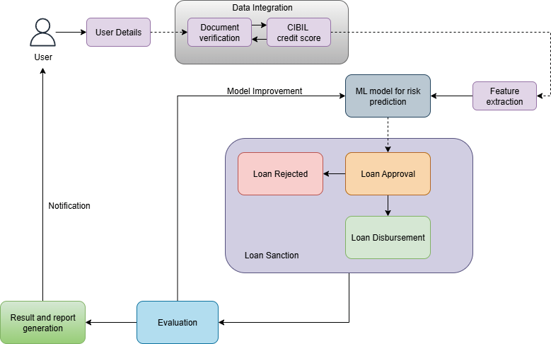
Fig: 1. Block diagram of the system.

This block diagram illustrates the flow of CredMill. The process begins with the User providing User Details, which are processed in the Data Integration stage involving Document verification and fetching the CIBIL credit score. These integrated data points are then used for Feature extraction to train or feed into an ML model for risk prediction. The model's output determines the Loan Sanction decision: either Loan Approval or Loan Rejected. If approved, it leads to Loan Disbursement. The overall result is subject to Evaluation, which provides a Model Improvement feedback loop to the ML model and also generates a Result and report generation that is sent as a Notification back to the User.

Modular diagram of the system

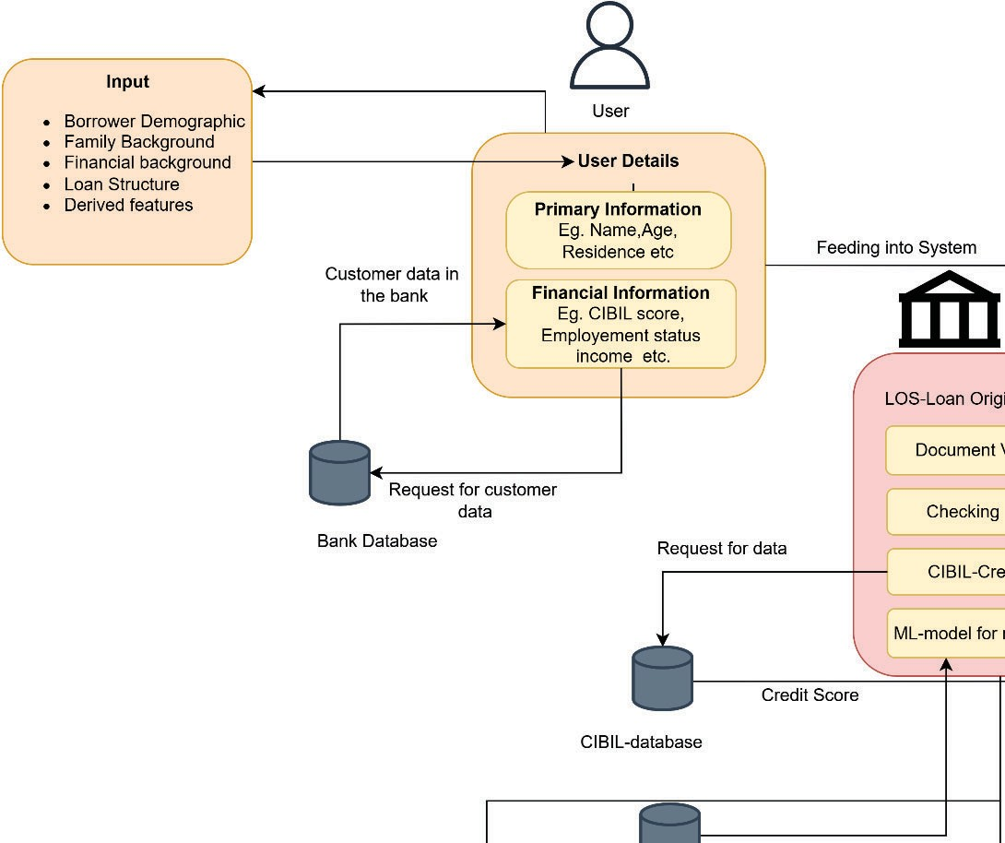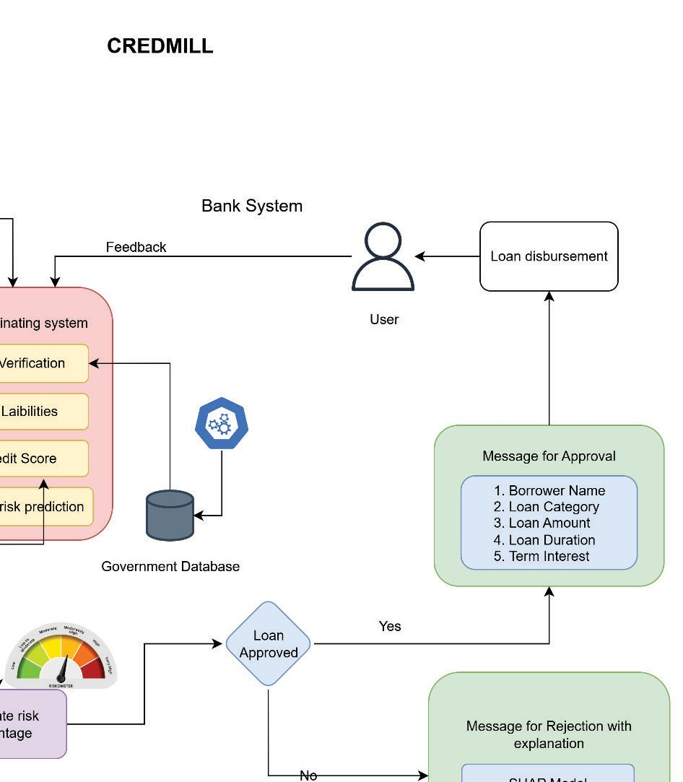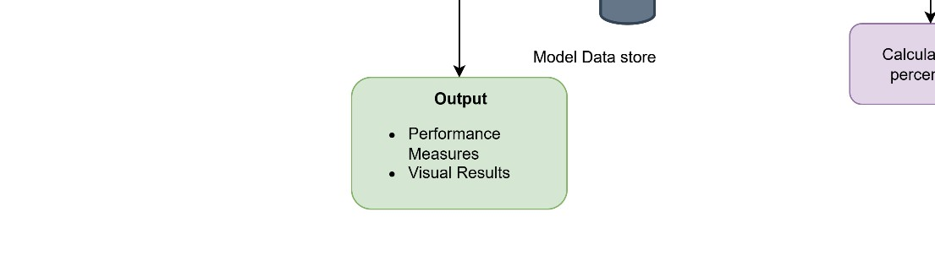

Fig 2: Modular Diagram of the system

Input and Data Acquisition:
The process starts with the User submitting User Details, which are categorized into Primary Information (e.g., Name, Age, Residence) and Financial Information (e.g., CIBIL score, Employment status, Income). The system aggregates data from multiple sources:
    - The Input block defines the main data categories fed into the system, including Borrower Demographic, Family Background, Financial background, Loan Structure, and Derived features.
    - The system makes a Request for customer data from the Bank Database (containing existing customer data) and a Request for data from the CIBIL-database to retrieve the Credit Score.
Loan Origination and Risk Prediction:
The aggregated information is fed into the LOS (Loan Origination System) within the Bank System. Key steps in this module include:
- Document Verification.
- Checking Liabilities.

- Fetching the CIBIL-Credit Score.
- The core ML-model for risk prediction processes the data.
- Based on the model's output, the system calculates risk percentage, which is visualized on a gauge.

Decision, Output, and Feedback:
The risk calculation leads to the Loan Approved decision (Yes/No):
    - If Yes (Loan Approved): A Message for Approval is generated, detailing the Borrower Name, Loan Category, Loan Amount, Loan Duration, and Term Interest. The approval is then passed to a human User (likely a bank officer) for Loan disbursement. The Government Database is also consulted, and feedback is provided to the Bank System.
    - If No (Loan Rejected): A Message for Rejection with explanation is generated, often utilizing explainable AI techniques like the SHAP Model and LIME Model to
provide transparency for the decision.

Detailed Design - Flowchart:
The below diagram depicts the detailed flow of the proposed system:

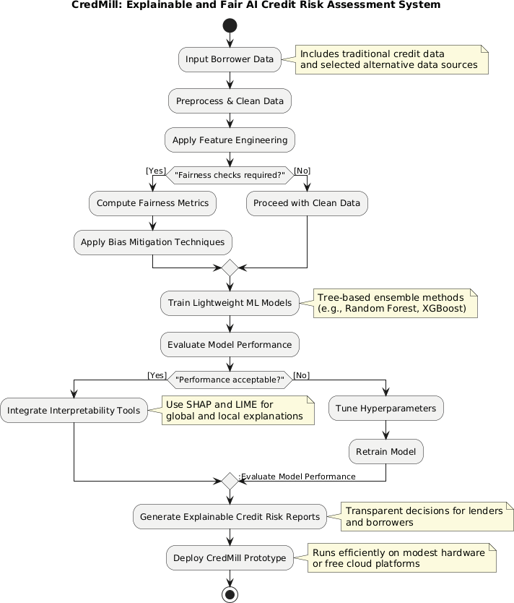

Fig. 3: Flowchart of the System

The proposed system goes as follows:
    - Input Data: The system starts by taking Borrower Data, which includes both
traditional credit data and selected alternative data sources.

    - Data Preparation: The data is then Preprocessed & Cleaned.

    - Feature Engineering: This step involves creating new features to improve model performance.

Fairness Check (Conditional Loop):
      - Yes: If Fairness checks are required, the system Computes Fairness Metrics
and then Applies Bias Mitigation Techniques before proceeding.
      - No: If not, it Proceeds with Clean Data.

    - Model Training: Lightweight ML Models are trained, typically using Tree-based ensemble methods like Random Forest or XGBoost.

Performance Evaluation (Conditional Loop):
      - The system Evaluates Model Performance.
      - No: If Performance is not acceptable, it Tunes Hyperparameters, Retrains Model, and then Re-evaluates Model Performance.
      - Yes: If Performance is acceptable, it moves to the next phase.

    - Interpretability: The system Integrates Interpretability Tools and uses methods like
SHAP and LIME for global and local explanations.

    - Reporting: Explainable Credit Risk Reports are generated to provide transparent decisions for lenders and borrowers.

    - Deployment: Finally, the CredMill Prototype is Deployed to run efficiently on modest hardware or free cloud platforms.

Project Scheduling & Tracking using Timeline / Gantt Chart
Project scheduling and tracking are essential to ensure the systematic execution of the CredMill project. A well-defined timeline helps in organizing tasks, allocating resources, and monitoring progress throughout the development lifecycle.

The project is divided into multiple phases, including problem identification, domain research, feature identification, system design, model development, integration of explainable AI (XAI), fairness auditing, testing, and deployment. Each phase is assigned a specific duration to maintain a structured workflow.

A Gantt chart is used to visually represent the project schedule, showing the start and end time of each activity. It helps in identifying task dependencies, tracking progress, and ensuring that milestones are achieved within the planned timeframe. Regular monitoring of the Gantt chart allows timely identification of delays and ensures corrective actions can be taken efficiently. This structured approach improves project management, enhances productivity, and ensures the successful completion of the CredMill system.

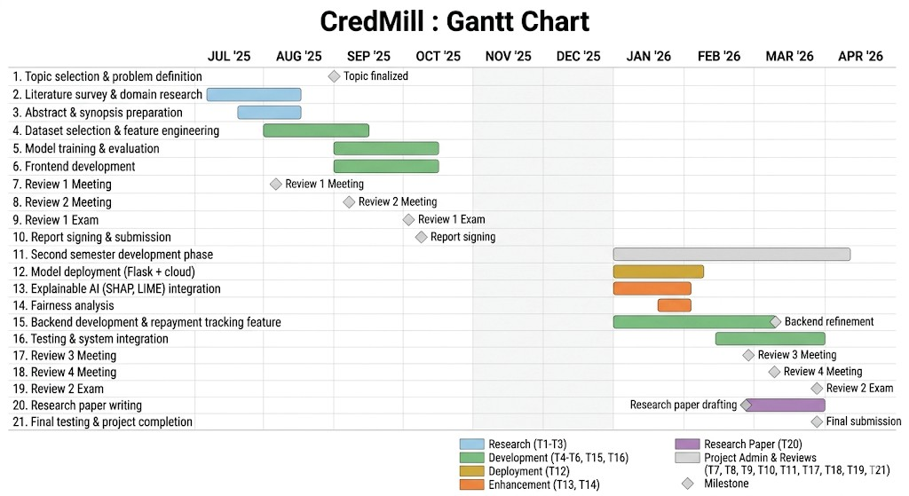

Fig. 4 Gantt Chart of the Project

This Gantt chart details the two-semester timeline for the 'CredMill: AI-Based Credit Risk Assessor' project. Running from July 2025 to April 2026, it is divided into clear phases: research and foundational development (T1-T3, blue) during the summer and early fall; core AI model development (T4-T6, T13, T14, green) across both semesters; system deployment (T12, yellow) and feature enhancement (T13, T14, orange) in the spring; and ongoing project administration and reviews (grey). Key milestones, marked by diamonds, are integrated throughout, including topic finalization, major review meetings and exams, and the start of research paper drafting. The comprehensive view tracks academic requirements, technical development, and final submission, ensuring a structured progression toward project completion.

Chapter 5: Implementation of the Proposed System

Methodology employed for development
The CredMill system follows a structured and iterative development methodology. The process begins with collecting borrower data, including both traditional financial data and alternative data sources.

The data is preprocessed and cleaned to handle missing values and inconsistencies. Feature engineering is performed to create meaningful attributes that improve model performance.

A fairness check is included as a conditional step. If required, fairness metrics are computed and bias mitigation techniques are applied before proceeding.

The system then trains machine learning models such as Random Forest, Gradient Boosting, and XGBoost. Model performance is evaluated, and if necessary, hyperparameter tuning and retraining are performed.

Finally, interpretability tools like SHAP are integrated, and the system generates explainable reports before deployment.

Algorithms and flowcharts for the respective modules developed
The CredMill system uses multiple machine learning algorithms for credit risk prediction. Linear Regression serves as a baseline model due to its simplicity and interpretability. Ridge and Lasso Regression improve model stability and perform feature selection.

Decision Tree models capture nonlinear relationships, while ensemble methods such as Random Forest and Gradient Boosting improve accuracy and robustness. XGBoost is selected as the final model due to its high performance and efficiency.

The system flow begins with data input, followed by preprocessing, feature engineering, fairness checking, model training, evaluation, interpretability, and deployment. Conditional loops ensure that fairness and performance requirements are satisfied before proceeding.

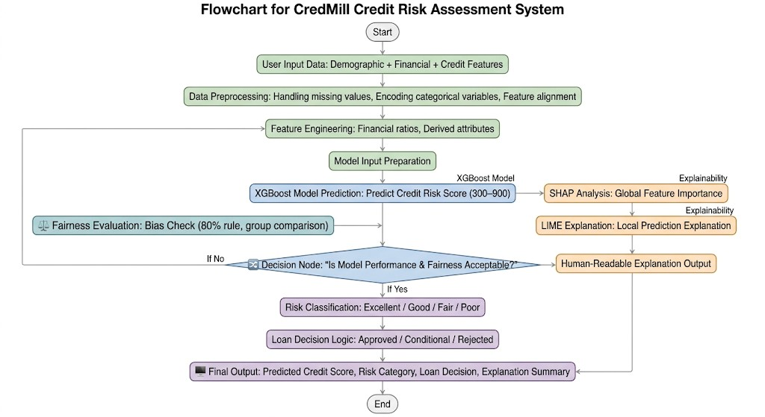

Fig. 5 Flowchart of Algorithms used

This flowchart outlines the CredMill Credit Risk Assessment System, a structured pipeline designed to evaluate loan applicants using machine learning. The process begins with collecting demographic and financial data, which undergoes preprocessing and feature engineering before being fed into an XGBoost model to predict credit scores. Parallel to the prediction, the system conducts a Fairness Evaluation (using the 80% rule) and generates explainability insights through SHAP and LIME analyses. A critical decision node then determines if the model’s performance and fairness are acceptable; if not, the system loops back to the feature engineering stage. Once approved, the system classifies risk, applies loan decision logic, and produces a final output that includes the credit score, risk category, and a human-readable explanation.

Datasets source and utilization
The CredMill system uses curated datasets containing both traditional and alternative credit-related features. Traditional data includes income, credit history, repayment behavior, and loan details.

The datasets are preprocessed to remove inconsistencies and normalize values. Feature engineering and selection techniques are applied to identify the most relevant attributes.

These datasets are used to train and evaluate multiple machine learning models using metrics such as MSE and R². Additionally, datasets are used for fairness auditing to ensure unbiased predictions across different groups.

Dataset used Link:
https://docs.google.com/spreadsheets/d/1-2VwO_fAjcen_Yy08McFN6oH2tWdAjCjGFF8lC UbEG0/edit?gid=804542799#gid=804542799
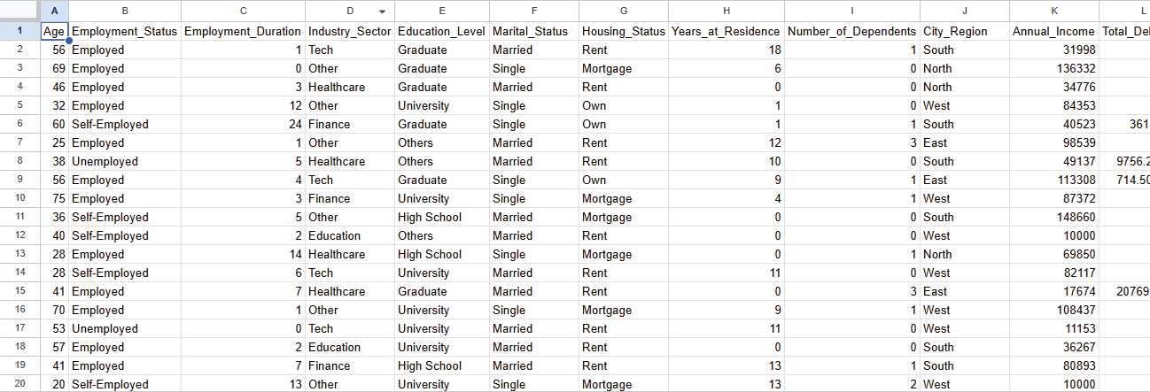

Fig 6. Dataset used

Chapter 6: Testing of the Proposed System

  - Introduction to testing
Testing is a critical phase in the development of CredMill, ensuring that each module—from data ingestion and ML model inference to explainability generation and fairness auditing—functions correctly, reliably, and transparently. Given that CredMill operates in a sensitive financial domain where incorrect predictions can have direct real-world consequences, rigorous testing is not merely a quality assurance step but an ethical requirement.

The testing strategy for CredMill was designed to validate the correctness of individual components as well as the integrated end-to-end pipeline. Special emphasis was placed on verifying the explainability outputs (SHAP and LIME), the fairness audit results, and the accuracy of the ML model's risk predictions. Testing was also conducted to ensure that the system performs efficiently on modest hardware and that the web-based interface provides a seamless experience to non-technical users such as loan officers.

  - Types of tests considered
The following testing methodologies were employed to validate CredMill's functionality, robustness, and reliability:

    - Unit Testing – Tested individual components such as data preprocessing functions, feature engineering logic, model inference calls, SHAP value computation, and fairness metric calculations in isolation.
    - Integration Testing – Verified the interaction between modules, such as the flow from data preprocessing → model prediction → SHAP/LIME explanation generation → Flask API response → React UI rendering.
    - Model Validation Testing – Evaluated the ML model's performance using standard metrics including Accuracy, Precision, Recall, F1-Score, and AUC-ROC across different data splits and cross-validation folds.
    - Explainability Testing – Confirmed that SHAP global feature importance plots and LIME local explanations are correctly generated and accurately reflect the model's decision factors for each borrower profile.

    - Fairness Testing – Assessed the model's output across demographic subgroups (e.g., gender, age group) using AIF360 and Fairlearn to detect and confirm mitigation of bias.
    - System Testing – Evaluated the complete end-to-end workflow in realistic scenarios—from borrower data submission to final loan decision with explanation.
    - Usability Testing – Assessed the web interface's ease of use by simulating interactions of non-technical users such as loan officers navigating risk scores, explainability dashboards, and the riskometer.
    - Performance Testing – Measured system response time and computational load during model inference to confirm that CredMill operates efficiently on standard hardware (8 GB RAM, mid-range CPU).
    - Security Testing – Checked for data exposure risks in API endpoints, validated input sanitization to prevent injection attacks, and verified that sensitive borrower data is handled securely.

Various test case scenarios considered

Test Case ID | Scenario | Expected Result | Input | Status
TC01 | Submit valid borrower profile for risk  assessment | Risk score  generated with loan approval/rejection decision | Complete borrower data with all  required fields | Pass
TC02 | Submit borrower profile with missing fields | System returns  validation error prompting user to fill required fields | Incomplete form (e.g., missing income field) | Pass
TC03 | Prediction for high-risk borrower profile | Loan rejected with high-risk percentage displayed on riskometer | Low CIBIL  score, high existing liabilities, irregular income | Pass
TC04 | Prediction for low-risk borrower profile | Loan approved  with approval message and loan details | High CIBIL  score, stable  income, low liabilities | Pass

TC05 | SHAP  explanation generated on rejection | SHAP values correctly highlight top contributing negative factors | Rejected borrower profile | Pass
TC06 | LIME local explanation for individual prediction | LIME generates readable explanation listing key features affecting decision | Single borrower input | Pass
TC07 | Fairness audit on demographic groups | AI360 Fairlearn computes fairness metrics and flags disparity if present | Dataset with  gender as sensitive attribute | Pass
TC08 | Bias mitigation applied before model training | Biased training dataset | Reweighting technique reduces demographic disparity in predictions | Pass
TC09 | Model performance evaluation | Test dataset split | AUC-ROC >  0.80, F1-score acceptable across classes | Pass
TC10 | API endpoint  returns correct JSON response | POST request  with borrower JSON payload | Flask API  returns risk score, decision, and explanation fields in  correct format | Pass
TC11 | UI riskometer renders correctly | Risk percentage value from model | Gauge visual reflects correct risk band (Low/Medium/ High) | Pass
TC12 | System tested on low-spec hardware | Standard laptop (8 GB RAM, Intel i5) | Inference completes within acceptable time (<5 seconds) | Pass

Table 5: Testing of the Project Website

  - Inference drawn from the test cases

    - All critical modules of the CredMill system—including data preprocessing, ML inference, SHAP/LIME explanation generation, fairness auditing, and the Flask API—passed their respective test cases successfully.
    - The ML model demonstrated consistent and acceptable performance across test data splits, with AUC-ROC and F1-score metrics meeting the predefined thresholds.
    - SHAP explanations accurately reflected the model's decision logic, with high-risk rejections consistently attributing negative outcomes to features such as low CIBIL score, high existing liabilities, and irregular income—validating the system's transparency.
    - LIME explanations provided coherent local rationales for individual predictions, confirming that the explainability module produces human-understandable outputs suitable for loan officers.
    - The fairness audit successfully detected demographic disparities in test scenarios, and the applied bias mitigation techniques (reweighing) reduced measurable unfairness without significant degradation in predictive accuracy.
    - The system performed well within the resource constraints of standard mid-range hardware, with model inference completing in under 5 seconds—confirming CredMill's suitability for small-to-medium financial institutions.
    - Input validation and error handling mechanisms functioned correctly, preventing system crashes from malformed or incomplete inputs.
    - Minor inconsistencies observed in LIME output stability (a known limitation of LIME) were documented and acknowledged as part of the system's constraints.
    - Overall, the testing phase confirmed that CredMill is functionally sound, explainable, fair, and deployable in resource-constrained environments as intended.

Chapter 7: Results and Discussion

Screenshots of User Interface (UI) for the respective module
This chapter summarizes the preliminary findings, highlighting key accomplishments and insights from the first semester of CredMill development. It is an intelligent credit risk assessment system designed to enhance resource efficiency, transparency, and fairness in financial evaluations. It uses a hybrid architecture that combines lightweight tree-based algorithms with selective neural components to balance accuracy and computational cost. The system integrates explainability through SHAP methods and supports fairness auditing and alternative data usage.

Home Page:
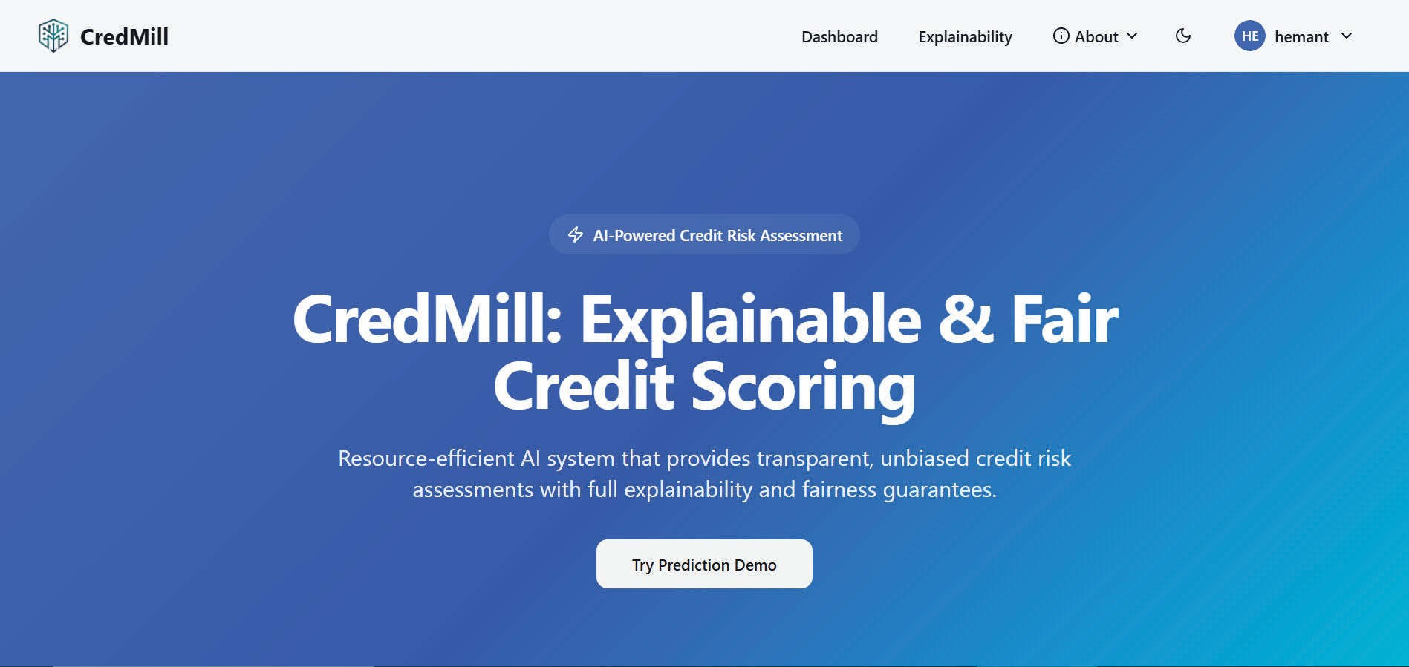
Fig: 7. Home page of the website

The home page serves as the primary landing interface for CredMill, positioning it as an AI-powered credit risk assessment platform. It emphasizes three core pillars: resource efficiency, transparency, and fairness guarantees in credit scoring. The clean, modern UI features a prominent call-to-action for users to either try a prediction demo or upload their own data for analysis. Navigation links at the top provide quick access to specialized modules like Model Evaluation and Fairness Audits.

Dashboard:
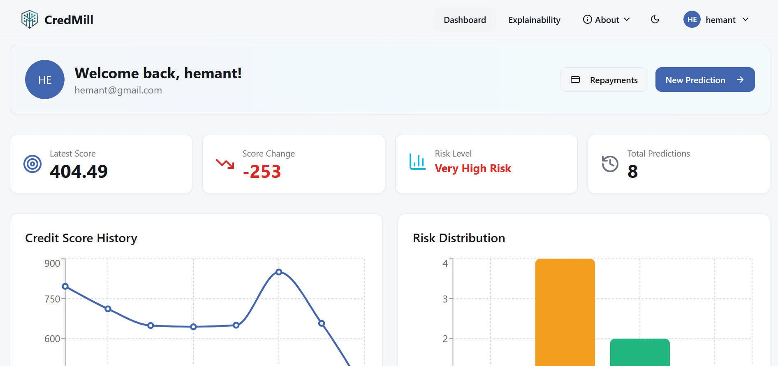
Fig. 8: User Dashboard
This dashboard provides a quantitative look at the platform's commitment to ethical AI by comparing protected versus unprotected groups. It utilizes the 80% rule threshold to evaluate key metrics including Approval Rate, False Positive Rate, False Negative Rate, and Equal Opportunity. Each metric is assigned a ratio and a "Pass" status, ensuring that the underlying model does not exhibit systemic bias against specific demographics. This level of auditing is crucial for regulatory compliance in financial services.

Input form:
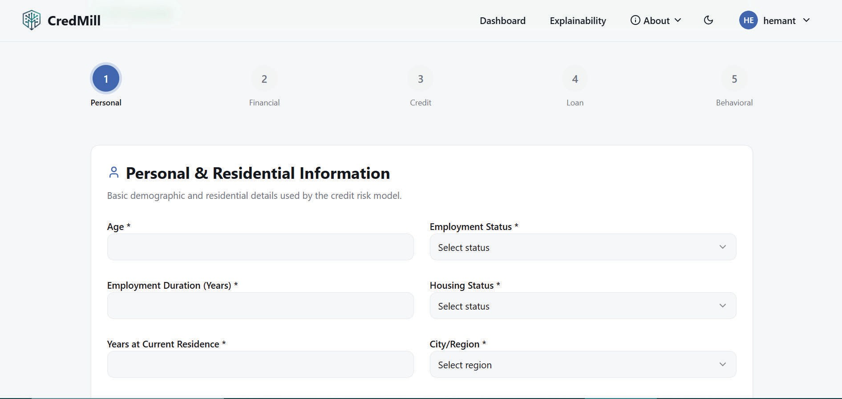
Fig. 9: The five sectioned form
This interface serves as the primary data ingestion layer, utilizing a multi-step "stepper" design to collect comprehensive user details across five distinct categories: Personal,

Financial, Credit, Loan, and Behavioral. By partitioning the input process, the system ensures a structured collection of features—such as employment duration, housing status, and demographic data—which are essential for the credit risk model to generate an accurate prediction. This modular approach improves user experience while ensuring that all multidimensional variables required for high-fidelity scoring are captured systematically.

Credit Score:
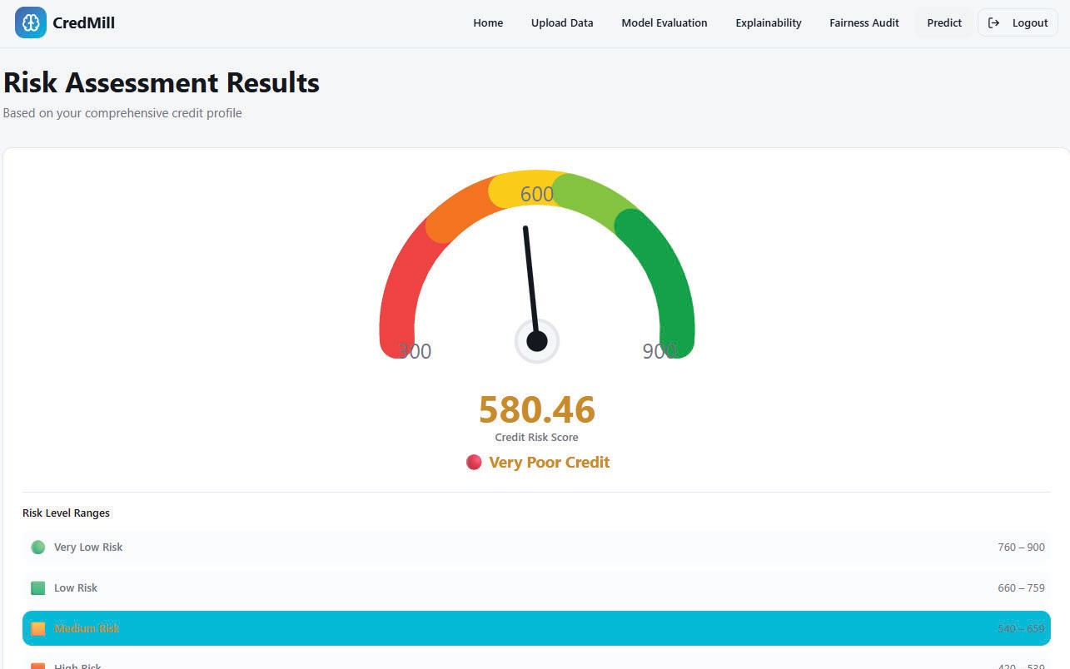
Fig 10: Riskometer - Shows the Credit Risk Score
The Riskometer provides a high-level, intuitive visual representation of an individual's creditworthiness on a scale from 300 to 900. It uses a gauge chart to categorize scores into four distinct tiers: Very Low Risk, Low Risk, Medium Risk, and High Risk. In the example shown, a score of 580.46 is flagged as "Very Poor Credit," falling within the Medium Risk range of 540–659. This summary view simplifies complex algorithmic outputs into a format that is immediately understandable for both lenders and borrowers.

Model Explanability Dashboard:
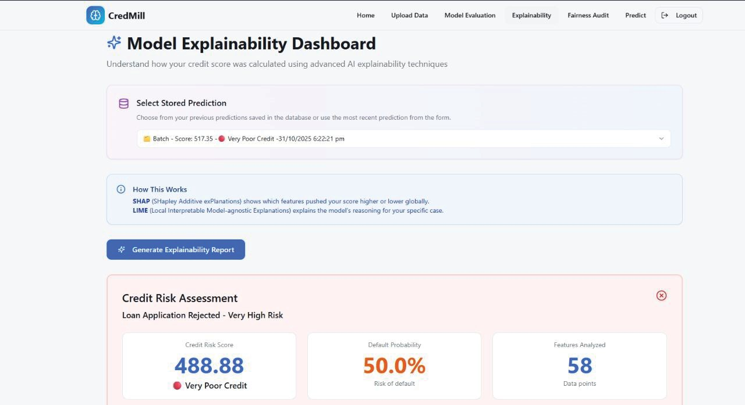
Fig. 11: Model explainability is shown in the dashboard
The Explainability Dashboard allows users to drill down into specific, individual predictions to understand the "why" behind a loan decision. It integrates two industry-standard techniques: SHAP for global feature importance and LIME for local, case-specific reasoning. The interface displays a summary of a rejected application, highlighting a high-risk default probability of 50.0% based on 58 analyzed data points. This dashboard is essential for providing applicants with actionable feedback on why their credit was rated a certain way.

SHAP:
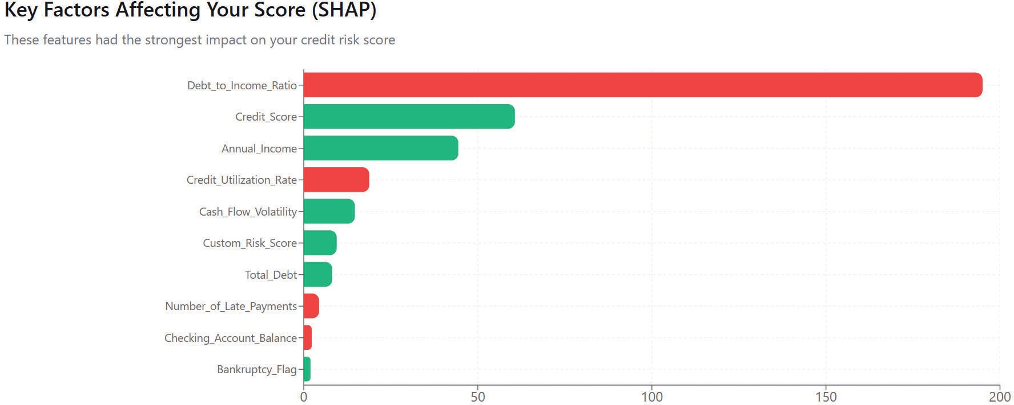

Fig. 12: Key factors that affect your score ( Explained by SHAP)

This visualization utilizes SHAP (Shapley Additive Explanations) values to provide "Global Explainability" by identifying which features most significantly influence the credit risk score. The horizontal bar chart ranks variables like Annual Income, Net Worth, and Total Assets, using color-coded indicators to show if a factor is "Risk Increasing" (red) or "Risk Reducing" (green). By quantifying the impact of each data point, the system moves away from "black box" AI, offering clear logic for its scoring decisions.

LIME Analysis:
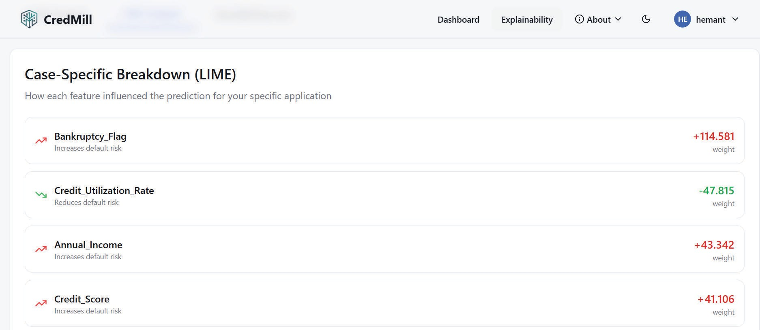
Fig 13: LIME Analysis
This visualization employs LIME (Local Interpretable Model-agnostic Explanations) to provide "Local Explainability" by deconstructing a single prediction into its contributing parts. Unlike global trends, this interface shows how specific features—such as Bankruptcy Flags or Annual Income—weighted the decision for one individual application. By assigning positive (red) and negative (green) weights to each variable, the system offers granular transparency, allowing users to understand the exact logical justification behind their specific credit risk assessment.

7. Summary
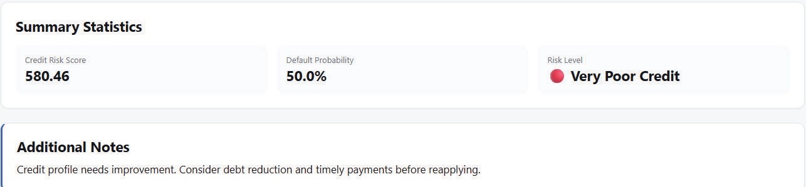
Fig. 14: Summary of the Result

The Summary of the Result serves as the final verdict of the assessment, distilling complex data into three critical data points: the Credit Risk Score, the Default Probability, and the final Risk Level. It provides a clear, high-level status (such as "Very Poor Credit") that is easily digestible for the end-user. Below the statistics, an "Additional Notes" section offers personalized advice, such as recommending debt reduction or timely payments before a reapplication. This prescriptive guidance adds a layer of coaching to the platform, helping users understand how to improve their financial standing over time.

7.2 Performance Evaluation measures
The performance of the CredMill system is evaluated using standard machine learning metrics to ensure accuracy and reliability. The primary evaluation metrics used are Mean Squared Error (MSE) and R-squared (R²), which help measure prediction error and model fit respectively.

In addition to these, cross-validation techniques are applied to ensure that the models generalize well to unseen data. Metrics such as AUC-ROC and F1-score are also considered to evaluate classification performance and balance between precision and recall.

The evaluation process ensures that the selected model not only provides accurate predictions but also maintains stability and consistency across different datasets.

Input Parameters / Features considered
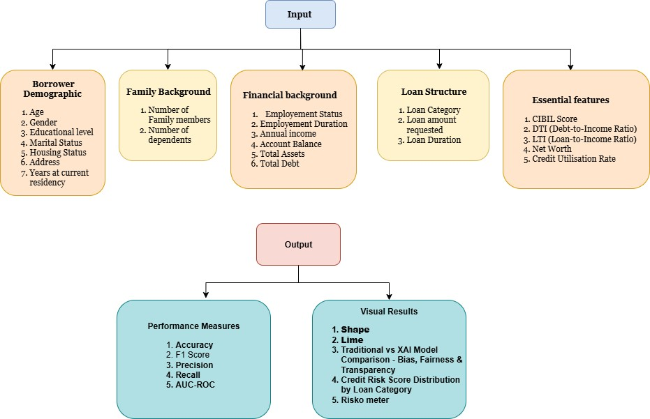
Fig 15: Input and Outputs features

This flowchart illustrates a Machine Learning framework for Credit Risk Assessment, divided into comprehensive input and output phases:
    - Data Inputs: The model ingests five categories of data: Borrower Demographics, Family Background, Financial Background, Loan Structure, and "Essential Features" like CIBIL score and debt-to-income ratios.
    - Performance Metrics: The output evaluates the model's predictive success using standard statistical measures, including Accuracy, F1 Score, Precision, Recall, and AUC-ROC.
    - Explainability (XAI): A significant focus is placed on visual interpretability through tools like SHAP and LIME to ensure transparency and bias detection.
    - Risk Visualization: The final results provide comparative analysis between traditional and XAI models, alongside intuitive visual aids like a "Risko meter" and score distributions.

Graphical and statistical output
To evaluate the predictive performance of the implemented models, we conducted a comprehensive comparative analysis using standard statistical benchmarks. The primary metrics selected for this evaluation include the Coefficient of Determination R2, Mean Absolute Error (MAE), and Mean Squared Error (MSE). These metrics provide a holistic view of each model's accuracy and its ability to generalize across the dataset. By visualizing these outputs side-by-side, we can identify which algorithms effectively capture the underlying data patterns and which ones suffer from high variance or bias. Figure 15 illustrates these performance discrepancies across the eight candidate models.
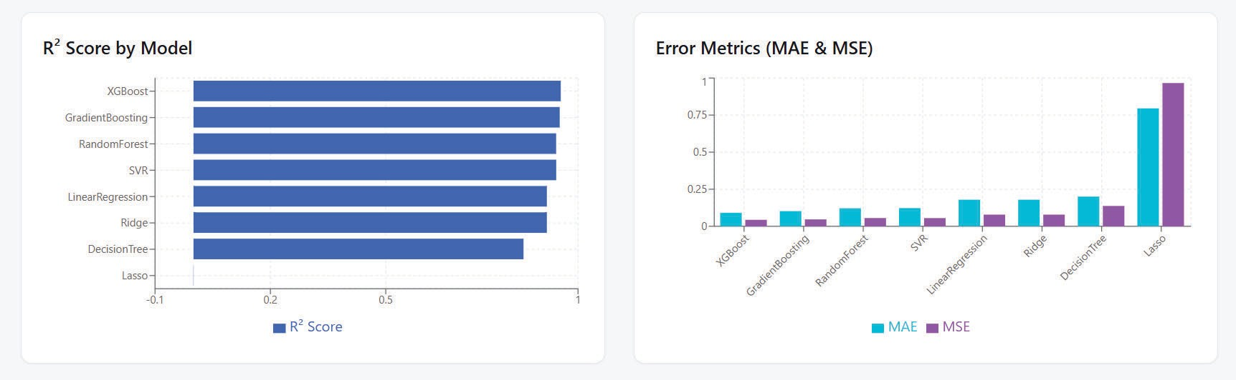

Fig. 16. Model Metrics Comparison
The graphical results clearly indicate that ensemble methods, specifically XGBoost and Gradient Boosting, outperformed traditional linear models in this specific use case. These

models achieved the highest R2 scores while maintaining significantly lower MAE and MSE values, suggesting superior precision in their predictions. Conversely, the Lasso regression model exhibited the poorest performance, showing a near-zero R2 and disproportionately high error rates, which likely points to an underfitting issue or an inability to handle the non-linear complexities of the features. Based on this statistical evidence, the XGBoost model is selected as the primary candidate for deployment due to its robust stability and minimal error margins.

Comparison of results with existing systems
The below are the comparative results obtained in the project model trainings:

Model Category | Your Project Results | Literature Benchmarks | Concise Comparison
Linear / Baseline (Linear, Ridge, Lasso) | MSE: 1045.5  - 3058.7 R²:  0.757 - 0.917 | Accuracy: 74.8%  - 86% AUC: 0.77  - 0.78 | Solid interpretable baselines, but fail to capture complex, non-linear borrower patterns.
Decision Tree | MSE: 1776.7  R²: 0.859 | Accuracy: 80%  AUC: 0.72 | Weakest ML performer; easily prone to overfitting and high variance.
Random Forest | MSE: 753.9  R²: 0.940 | Accuracy: 74.3%  - 90% AUC: 0.77  - 0.85 | Highly robust; effectively addresses decision tree overfitting through ensemble averaging.
Gradient Boosting | MSE: 614.6  R²: 0.951 | Accuracy: 92%  AUC: 0.87 | Top overall performer; builds models sequentially to minimize errors and captures complex interactions.
XGBoost | MSE: 692.0  R²: 0.945 | Accuracy: 75.3%  - 99.4% AUC:  0.70 - 0.72 | Fast, efficient, and scalable; widely adopted in FinTech for balancing speed with high accuracy.

Table No. 6 : Model Comparisons

Among all tested models, Gradient Boosting achieved the highest accuracy, followed closely by XGBoost and Random Forest, making them ideal for credit risk prediction tasks.
Considering speed, interpretability, and deployment efficiency, XGBoost was chosen as the final production model for CredMill

7.6 Inference drawn
The results obtained from the CredMill system highlight its effectiveness in addressing key challenges in credit risk assessment. The integration of machine learning models with explainability and fairness mechanisms ensures that the system is both accurate and transparent.

The use of lightweight models and efficient design enables deployment on low-resource environments without compromising performance. The system successfully demonstrates the feasibility of combining predictive analytics with ethical AI principles.

Overall, the findings indicate that CredMill is a reliable and practical solution for credit risk evaluation, capable of improving decision-making processes while maintaining fairness, transparency, and efficiency.

Chapter 8: Conclusions

Limitations
The CredMill project, while establishing a strong foundation, is currently limited to the initial phase of development. This semester’s work has primarily focused on detailed domain study, feature identification, and system design planning rather than full implementation. As a result, the system has not yet been deployed or tested in real-world financial environments.

Additionally, the integration of machine learning models, explainable AI (XAI), and fairness auditing mechanisms is planned for future phases and has not yet been practically validated. Challenges such as handling real-world data variability, ensuring scalability, and integrating with existing financial systems remain to be addressed in subsequent stages.

Conclusion
The CredMill project represents a significant step toward bridging the gap between high-performance credit scoring systems and the need for transparency, fairness, and accessibility in small-to-medium-scale lending environments. This semester’s work has laid a strong foundation through detailed domain study, feature identification, and system design planning.

The key innovation of CredMill lies in its resource-efficient design, allowing explainable and ethical credit scoring to run effectively on modest hardware without depending on costly cloud infrastructure or proprietary APIs.

By the conclusion of the project, the team aims to deliver a transparent AI model that provides not just risk predictions but interpretable explanations behind every decision, a fair and auditable framework that detects and mitigates potential demographic biases, and an operationally practical system deployable in small financial institutions or educational research setups.

Ultimately, CredMill will demonstrate how responsible AI can be implemented within real-world credit assessment scenarios—balancing predictive performance, computational efficiency, and ethical accountability. The work underscores the team’s commitment to developing trustworthy, human-centric financial AI solutions that can inspire future research and adoption in equitable fintech systems.

Future Scope
Through the next development phase, the project will evolve into a working prototype that integrates machine learning, explainable AI (XAI), and fairness auditing. Future work will involve implementing and testing machine learning models on real datasets, incorporating explainability techniques to enhance transparency, and developing fairness auditing mechanisms to ensure unbiased decision-making.

Further improvements will focus on making the system more robust, scalable, and suitable for deployment in practical environments such as small financial institutions and academic research setups. Continuous optimization will also be carried out to maintain efficiency while ensuring ethical and interpretable AI-driven credit scoring.

Chapter 9: References

IEEE Standard Journal Papers
- “An Analytical Approach to Credit Risk Assessment Using Machine Learning Models,”
Decision Analytics Journal, vol. 16, 2025.

- “Explainable AI in Credit Scoring: Improving Transparency in Loan Decisions,” J. Inf. Syst. Eng. & Mgmt., 2025.

- “Fairness in Credit Scoring: Assessment, Implementation and Profit Implications,” Eur. J. Oper. Res., vol. 297, 2022.

- “Machine Learning Algorithms for Credit Risk Assessment: An Economic and Financial Analysis,” Int. J. Management Technology, vol. 10, no. 1, pp. 109–133, 2023.

- “Enhancing Credit Risk Management Through Revalidation and Accuracy in Financial Data,” Int. J. Res. Publication and Reviews, vol. 5, no. 11, 2024.

- “Theoretical Frameworks in AI for Credit Risk Assessment: Towards Banking Efficiency and Accuracy,” Int. J. Scientific Research Updates, vol. 7, no. 1, pp. 092–102, 2024.

Conference Papers
- “Early Warning System for Monitoring Credit Risk at a Global Bank,” in Data-Driven Explainable Solution for Negative Migration Prediction, 2025.

- “CRAM: A Credit Risk Assessment Model by Analyzing Different ML Algorithms,” in
Proc. Int. Conf. on Emerging Trends in Eng. and Tech., 2021.

Thesis
- “Utilizing AI for Improved Credit Risk Assessment,” Harrisburg University, 2025.

Books
- J. Hull, Credit Risk Modeling Using AI and Machine Learning. Pearson, 2023.

- Artificial Intelligence in Finance: The Road Ahead. MIT Press, 2024.

- Responsible AI in Financial Services. OECD, 2023.

Magazine Article
- “Fairness and Transparency in Credit Risk Models,” Harvard Business Review, 2024.

Appendix

List of Figures

Fig. No. | Heading | Page no.
1 | Block Diagram | 17
2 | Modular Diagram | 18
3 | Flowchart of System | 20
4 | Gantt Chart | 22
5 | Flowchart of Algorithms | 24
6 | Dataset Used | 25
7 | Home page of the website | 30
8 | User Dashboard | 31
9 | The five Sectioned Input Form | 31
10 | Riskometer - Credit Score Visualization | 32
11 | Model explainability dashboard | 33
12 | Key factors that affect your score (SHAP) | 33
13 | LIME Analysis | 34
14 | Summary of the Result | 34
15 | Input and Output features | 35
16 | Model Metrics Comparison | 36

- List of tables

Table Number | Heading | Page no.
1 | Study of Existing Systems | 3
2 | Literature Survey | 6
3 | Patent Research Summary | 9
4 | Comparing with Existing Systems | 10
5 | Testing of Project Website | 27
6 | Model Comparison | 37

Designing an AI-Based Credit Risk Assessment System for Predictive Financial Analytics
*Note: Sub-titles are not captured in Xplore and should not be used

Hemant Satam Computer Engineering V.E.S.I.T
Mumbai, India 2022.hemant.satam@ves.ac.in

Suryanarayan Panigrahy Computer Engineering V.E.S.I.T
Mumbai, India 2022.suryanarayan.panigrahy@ves.ac.in
Dr. Gresha Bhatia Computer Engineering V.E.S.I.T
Mumbai, India gresha.bhatia@ves.ac.in
Harsh Patil Computer Engineering
V.E.S.I.T
Mumbai, India 2022.harsh.patil@ves.ac.in

Gaurav Gupta Computer Engineering V.E.S.I.T
Mumbai, India 2022.gaurav.gupta@ves.ac.in

Abstract—Credit risk assessment is important for financial institutions to support lending decisions and reduce default losses. Traditional models fail to capture the pattern from the modern financial data which has various demography and attributes. Due to advancement in technology like artificial intelligence and machine learning it has improved predictive accuracy, fairness, and operational efficiency in credit scoring systems. This paper presents an AI-based Credit Risk Assessment System which is a web application that uses supervised machine learning techniques which helps to predict borrower creditworthiness and compare performance of different ML models. It helps to make real time decisions by ensuring scalability and model interpretability. The results show that with the help of Machine LEarnning techniques and its models it is possible to predict the borrower credit risk with more accuracy and give possible reasons for any decisions using explainable AI. The study also discusses the limitations of the proposed system and future scope to improve the model performance in order to make it more reliable and efficient.

Keywords—AI-based Credit Scoring, Credit Risk Assessment, Machine Learning, Financial Analytics, Predictive Modeling, Explainable AI, Risk Prediction, FinTech Systems
  - INTRODUCTION
Credit risk assessment is a very important aspect from the financial institutions point of view where they have to make certain financial decisions about the borrower probability to default or optimizing the landing strategies. Traditionally, statistical models such as logistic regression were mostly used for credit scoring. However, due to advancement in technology like artificial intelligence and machine learning it has improved predictive accuracy, fairness, and operational efficiency in credit scoring systems significantly [2], [10].
Modern credit risk systems use ensemble learning, gradient boosting, and deep neural architectures to reduce biases and take the early detection of default borrowers [7], [16]. Furthermore, in automated credit scoring systems the fairness-aware modeling is used to reduce the biases in the outcomes [1].Use of explainable AI such as SHAP and LIME in credit scoring systems help to give proper reasons to output and ensures transparency [8], [14].
The financial data may be present in unstructured or semi-structured format which can be handled using transformer-based models and language models[13], [17],

XXX-X-XXXX-XXXX-X/XX/$XX.00 ©20XX IEEE
showing the expanding role of AI in financial analytics. Despite these advancement there is some gap that still exist like many existing systems are research oriented only, problem during deployment and user accessible-interface
Considering these gaps the paper proposes an AI-based Credit Risk Assessment System implemented as a web-based application which allows real time evaluation of borrower credentials and accurate prediction with the help machine learning model. The System follows a structured pipeline to build the model and test it right from data preprocessing to model evaluation .

The further part of the paper presents the methodology, proposed system architecture, experimental analysis, and future research directions.
  - LITERATURE SURVEY
Recent advancements in modern technology like Artificial Intelligence (AI) and Machine Learning (ML) helps to improve the efficiency of credit risk assessment systems significantly. Researchers have explored various dimensions including predictive accuracy, fairness-aware modeling, explainable AI (XAI), deep learning architectures, transformer-based models, and Large Language Models (LLMs) for intelligent credit scoring. The following table summarizes major contributions from recent studies between 2022 and 2026, highlighting their methodologies, key findings, and identified limitations.
- Research Paper Table:

TABLE I. LITERATURE REVIEW SUMMARY

Sr. No | Name of Research Paper | Publisher, Year of Publishing | Summary of Research Paper | Reference
1 | Fairness in | European | Abstract: This Paper | Kozodoi, N., Jacob,
 | credit | Journal of | studies how to make | J., & Lessmann, S.
 | scoring: | Operational | the ML model fair. It | (2022). Fairness in
 | Assessment, | Research, | discusses different | credit scoring:
 | implementati | 2022 | methods to evaluate | Assessment,
 | on and profit |  | the fairness of the | implementation and
 | implications |  | model. It compare | profit implications.
 |  |  | these methods with | European Journal of
 |  |  | real world credit | Operational
 |  |  | scoring data | Research, 297(3),
 |  |  |  | 1083–1094.

 |  |  | Conclusion: The study says that “Separation” is the best method to evaluate fairness in credit scoring. Banks can reduce the unfair bias while still making profit out of it.
2 | Machine | Neural | Abstract:This research | Shi, S., Tse, R.,
 | learning-driv | Computing | paper reviewed 76 | Luo, W.,
 | en credit risk: | and | research papers from | D’Addona, S., &
 | a systemic | Applications, | the last 8 years to | Pau, G. (2022).
 | review | 202 | understand which ML | Machine
 |  |  | models and methods | learning-driven
 |  |  | are used in the credit | credit risk: a
 |  |  | scoring system and | systemic review.
 |  |  | how the performance | Neural Computing
 |  |  | was. | and Applications,
 |  |  | Conclusion: They | 34,
 |  |  | found that deep | 14327–14339.,ph17
 |  |  | learning and ensemble | 062068
 |  |  | learning perform
 |  |  | better than traditional
 |  |  | models. But several
 |  |  | problems like
 |  |  | unbalanced data,
 |  |  | different datasets, and
 |  |  | lack of transparency
 |  |  | still exist
3 | Credit Risk | International | Abstract: This | Malik, P., Anand,
 | Assessment | Journal of | research shows how | A., Baliyan, A. K.,
 | and Fraud | Scientific | ML models and | Dongre, A., &
 | Detection in | Research & | methods can be used | Panwar, P. (2024).
 | Financial | Engineering | in financial | Credit Risk
 | Transactions | Trends, 2024 | transactions. This | Assessment and
 | Using |  | research is focuses on | Fraud Detection in
 | Machine |  | Building models | Financial
 | Learning |  | following all the step | Transactions Using
 |  |  | and testing it for risk | Machine Learning.
 |  |  | assessment and fraud | International
 |  |  | detection | Journal of Scientific
 |  |  | Conclusion: It says | Research &
 |  |  | that Machine Learning | Engineering Trends,
 |  |  | can really improve the | 10(2), 433-440.
 |  |  | credit risk assessment
 |  |  | by making it more
 |  |  | accurate and efficient.
 |  |  | With changing market
 |  |  | conditions the model
 |  |  | adaptation capability
 |  |  | still remains the
 |  |  | question.
4 | Enhancing | International | Abstract: This paper | Nwachukwu, G.
 | Credit Risk | Journal of | looks at how accurate | (2024). Enhancing
 | Management | Research | data and regular | Credit Risk
 | Through | Publication | checking , | Management
 | Revalidation | and Reviews, | revalidation are | Through
 | and Accuracy | 2024 | important for | Revalidation and
 | in Financial |  | collecting the correct | Accuracy in
 | Data: The |  | borrower data, | Financial Data: The
 | Impact of |  | managing loans | Impact of Credit
 | Credit |  | properly and | History Assessment
 | History |  | assessing credit | on Procedural
 | Assessment |  | history. | Financing.
 | on |  | Conclusion: It | International
 | Procedural |  | suggests a combined | Journal of Research
 | Financing |  | approach where along | Publication and
 |  |  | with AI and predictive | Reviews, 5(11),
 |  |  | analytics there should | 631-644.
 |  |  | be data management
 |  |  | and human
 |  |  | supervision to manage
 |  |  | credit risk effectively.
5 | Theoretical | International | Abstract:This Paper | Edunjobi, T. E., &
 | frameworks | Journal of | studies the concept of | Odejide, O. A.
 | in AI for | Scientific | Machine Learning and | (2024). Theoretical
 | credit risk | Research | Natural Language | frameworks in AI
 | assessment: | Updates, | Preprocessing(NLP) | for credit risk
 | Towards | 2024 | techniques and how | assessment:
 | banking |  | they can help in | Towards banking
 | efficiency |  | increasing speed and | efficiency and
 | and accuracy |  | accuracy of traditional | accuracy.
 |  |  | models. | International

 |  |  | Conclusion:It suggests that on using AI responsibly along with Explainable AI with Human involvement we can create more accurate, reliable, fair financial system | Journal of Scientific Research Updates, 7(1), 092–102.
6 | AI-Based Credit Risk Assessment and Intelligent Matching Mechanism in Supply Chain Finances | Journal of  Theory and  Practice in Economics and Management, 2025 | Abstract:This paper introduces a new AI based system for supply chain finance. It predicts the credit score by leveraging. It also matches lenders and borrower smartly combined model as (XGBoost + BiLSTM)  Conclusion: The results show that the prediction accuracy is being improved and reduced the loan approval time by 61%. It helps small businesses to get the loans ,very easily. | Pal, P., Wang, Z.,  Zhu, X., Chew, J.,  Pruś, K., & Wei, X. (2025). AI-Based  Credit Risk  Assessment and Intelligent Matching Mechanism in Supply Chain Finance. Journal of Theory and Practice in Economics and Management, 2(3),  1–9
7 | An analytical approach to credit risk assessment using machine learning models | Decision Analytics Journal, 2025 | Abstract: The study creates and Early Warning System (EWS) by using ML model with help of customer past data and past events to predict the financial problem early Conclusion: They found that Random Forest performs best in detecting problems early and tools like SHAP helps to explain the output in a better way. | Machado, M. R.,  Chen, D. T., & Osterrieder, J. R. (2025). An  analytical approach to credit risk assessment using machine learning models. Decision Analytics Journal, 16, 100605.
8 | Explainable AI in Credit Scoring: Improving Transparency in Loan Decisions | Journal of Information Systems Engineering and Management, 2025 | Abstract: This study uses advance machine learning technique along with explainable AI to make Credit Scoring System to make the decision easier and  understandable Conclusion: The Study concluded that AI models give better Accuracy and Explainable AI help us to follow rules, reduce bias, and build trust with customers with the explanation of the output avoiding Black Boxing. | Mujo, A., Nikolla, S., Hoxha, E., & Pelivani, E. (2025). Explainable AI in Credit Scoring: Improving Transparency in Loan Decisions.  Journal of  Information Systems Engineering and Management, 10(27s).
9 | Interpretable LLMs for Credit Risk: A Systematic Review and Taxonomy | Manuscript under review (Preprint), 2025 | Abstract: This study reviews the 60 papers studying how Large Language Models (LLM) are used in credit risk. They organised all the papers according to models, data types, explainability and application.  Conclusion: They found that LLM based and Hybrid models have strong potential to make better scoring systems. But more research and | Golec, M., &  AlabdulJalil, M. (2025).  Interpretable LLMs for Credit Risk: A Systematic Review and Taxonomy. Manuscript under review.

investigation is
required in
consistency,fairness and incorrect outputs
10 | Transforming | Journal of | Abstract: The study | Roy, J. K., & Vasa,
 | credit risk | Infrastructure | reviewed all the | L. (2025).
 | assessment: | , Policy and | research on AI and | Transforming credit
 | A systematic | Development | Machine Learning | risk assessment: A
 | review of AI | , 2025 | techniques using | systematic review
 | and machine |  | PRISMA and ADO | of AI and machine
 | learning |  | methods in credit risk | learning
 | applications |  | systems. They | applications.
 |  |  | investigate how | Journal of
 |  |  | different research uses | Infrastructure,
 |  |  | data , methods and | Policy and
 |  |  | their outcome on | Development, 9(1),
 |  |  | credit risk for | 9652.
 |  |  | individuals and
 |  |  | companies.
 |  |  | Conclusion: They
 |  |  | found that Machine
 |  |  | Learning and Deep
 |  |  | Learning perform
 |  |  | better than traditional
 |  |  | Models. They also
 |  |  | suggest that future
 |  |  | works should focus on
 |  |  | models that are easy
 |  |  | to understand and can
 |  |  | assess the risk in real
 |  |  | time without bias.
11 | AI and | Independent | Abstract: This paper | Dil, A. R. (2025).
 | Machine | Paper / | explains how AI and | AI and Machine
 | Learning in | Whitepaper, | Machine Learning | Learning in Credit
 | Credit Risk | 2025 | improve the credit risk | Risk Assessment.
 | Assessment |  | assessment by
 |  |  | analyzing the
 |  |  | unstructured data and
 |  |  | predicting the loan
 |  |  | default more
 |  |  | accurately as
 |  |  | compared to
 |  |  | traditional methods
 |  |  | Conclusion:It suggests
 |  |  | that use of
 |  |  | Explainable AI is very
 |  |  | important to handle
 |  |  | ethical issues, ensure
 |  |  | fairness and help in
 |  |  | decision making.
12 | AI-Powered | European | Abstract: This paper | Duvalla, V. R.
 | Credit Risk | Journal of | explains how AI is | (2025). AI-Powered
 | Assessment: | Computer | used in FinTech | Credit Risk
 | Transforming | Science and | lending to assess the | Assessment:
 | Lending in | Information | people by using the | Transforming
 | FinTech | Technology, | alternative data who | Lending in FinTech.
 |  | 2025) | don’t have the credit | European Journal of
 |  |  | history. | Computer Science
 |  |  | Conclusion: It | and Information
 |  |  | concludes that AI | Technology, 13(23),
 |  |  | systems can help to | 115-131.
 |  |  | reduce loan default
 |  |  | and help more people
 |  |  | access the financial
 |  |  | benefits as long as
 |  |  | these systems are used
 |  |  | in a fair and ethical
 |  |  | way.
13 | Enhancing | Independent | Abstract: This study | Siphuma, E., & Van
 | Credit Risk | Paper / | tests and eva;uate | Zyl, T. (2025).
 | Assessment | Preprint, | advanced deep | Enhancing Credit
 | through | 2025 | learning models | Risk Assessment
 | Transformer- |  | (CNN-SFTransformer | through
 | Based |  | and | Transformer-Based
 | Machine |  | GRU-Transformer) in | Machine Learning
 | Learning |  | order to improve | Models.
 | Models |  | accuracy and
 |  |  | prediction power.
 |  |  | Conclusion: They
 |  |  | found that these
 |  |  | transformer models
 |  |  | help to make
 |  |  | predictions more

 |  |  | accurately and make smarter targeted decisions in credit scoring.
14 | Explainable | IOSR Journal | Abstract: This paper | Oyeyemi, D. O.,
 | AI For Credit | Of | represents a system | Okosieme, O. O.,
 | Risk | Economics | which is built by | Idowu-Kunlere, O.,
 | Assessment: | and Finance, | combining machine | Julius, E. A., &
 | Integrating | 2025 | learning with | Nwinyi, I. P.
 | Machine |  | explainable AI | (2025). Explainable
 | Learning |  | methods (like SHAP | AI For Credit Risk
 | With |  | and LIME) to make | Assessment:
 | Business |  | accurate predictions | Integrating Machine
 | Analytics |  | and easy to | Learning With
 |  |  | understand output. | Business Analytics.
 |  |  | Conclusion:It | IOSR Journal Of
 |  |  | concludes that using a | Economics and
 |  |  | blend of traditional | Finance, 16(5),
 |  |  | model, modern ML | 63-72.
 |  |  | and explainable AI
 |  |  | which can give more
 |  |  | accurate and clear
 |  |  | results, helps to build
 |  |  | trust for both lenders
 |  |  | and borrowers.
15 | Explainable | SRM | Abstract: This paper | Shreya, & Pathak,
 | Artificial | University | represents a system | H. (2025).
 | Intelligence | (Preprint), | that uses the models | Explainable
 | Credit Risk | 2025 | like XGBoost, | Artificial
 | Assessment |  | LightGBM, and | Intelligence Credit
 | using |  | Random Forest, along | Risk Assessment
 | Machine |  | with explainable AI | using Machine
 | Learning |  | methods to make | Learning. SRM
 |  |  | better predictions | University.
 |  |  | Conclusion: It found
 |  |  | that LightGBM model
 |  |  | gives more accurate
 |  |  | result for business use
 |  |  | and create visual
 |  |  | reports of the result to
 |  |  | make people
 |  |  | understand loan
 |  |  | decision clearly
16 | Deep | Research | Abstract: This | Taiwo, B. D.
 | Learning | Square, 2026 | research identifies | (2026). Deep
 | Architectures |  | how advanced deep | Learning
 | for Credit |  | learning models like | Architectures for
 | Risk |  | (LSTM, GRU, and | Credit Risk
 | Assessment |  | Transformers) can | Assessment.
 |  |  | help to predict loan | Research Square.
 |  |  | default using borrower
 |  |  | behaviour over time.
 |  |  | Conclusion:It found
 |  |  | that when
 |  |  | Transformer models
 |  |  | are combined with
 |  |  | other models and
 |  |  | explainability tools, it
 |  |  | gives more accurate
 |  |  | results and more
 |  |  | accurate prediction.
17 | LendNova: | AAAI | Abstract: This paper | Shamsi, K.,
 | Towards | Workshop on | introduces an | Novokmet, D.,
 | Automated | Agentic AI in | automated system | Peters, J., Liu, M.
 | Credit Risk | Financial | named as “LendNova” | L., Edwards, P. K.,
 | Assessment | Services, | which uses language | & Khoshdel, V.
 | with | 20269 | models to understand | (2026). LendNova:
 | Language |  | raw and complex | Towards Automated
 | Models |  | credit report text | Credit Risk
 |  |  | without manual data | Assessment with
 |  |  | preparation. | Language Models.
 |  |  | Conclusion: The study | AAAI 2026
 |  |  | concluded that | Workshop on
 |  |  | “LendNova” is a | Agentic AI in
 |  |  | scalable system and | Financial Services.
 |  |  | shows that language
 |  |  | models can directly
 |  |  | understand financial
 |  |  | data and make
 |  |  | accurate predictions.

- Analyzing the Research Gap
After studying the various literatures it shows that while fairness-aware credit scoring models have been systematically evaluated [1], and deep learning methods perform well with traditional statistical models [2], some challenges still remain related to model interpretability and robustness.. Several studies focus on the integration of Explainable AI techniques such as SHAP and LIME to address the problem of black-box [8], [14], [15], but still practical deployment of these frameworks has not been implemented yet. Performance can be improved with the help of Transformer-based and hybrid architectures[13], [16], but they are difficult and heavy to implement, they require high computational power [9].
Additionally, while supply chain finance models and intelligent matching systems have shown desired operational efficiency gains [6], most of the existing systems focus either on model accuracy or interpretability alone, but fail to provide a fully integrated end-to-end deployable system. Papers further discuss persistent research gaps in fairness control mechanisms, real-time adaptability, and ethical AI governance [2], [10], [12]. The recent language-model-based systems have shown potential for automated financial text interpretation [17], yet they are difficult to implement with the unstructured and semi-structured financial data.
These research papers clearly show the research gap for a practical, web-deployable AI-based credit risk assessment system that uses machine learning models with interpretability mechanisms, structured preprocessing, and better UI for interacting with predicted results. The proposed system aims to resolve these gaps by combining predictive performance, explainability, and real-time deployment capability within a combined framework.
  - METHODOLOGY
The credit risk assessment system uses the German Credit Risk dataset, along with synthetic feature engineering to create a complete dataset of 10,000 rows. The dataset contains attributes like financial and demographic data, such as borrower age, employment status, and credit history, which are important for predicting creditworthiness and reducing loan defaults.
The system includes preprocessing, feature engineering, and fairness checks in order to improve effectiveness and transparency of the model. Encoding of Categorical features is done, and financial ratios are derived to improve predictive power. Different types of regression models, including XGBoost, are tested and a risk band classification layer and explainability tools like feature importance and LIME are added to improve accuracy and fairness in decision-making.
- Data Collection and Synthesis
The System uses a German financial dataset with many attributes and also further extended with some synthetic features to improve the model performance. The final dataset consists of 10,000 rows with 46 column attributes like financial and demographic data, such as borrower age, employment status, and credit history etc.
Key feature categories include:
- Demographic attributes (Age, Marital Status, Employment Status)

- Financial indicators (Annual Income, Total Debt, Net Worth)

- Credit behavior metrics (Credit Utilization Rate, Late Payments, Delinquency History)

- Loan-related parameters (Loan Amount Requested, Loan Term Months, Collateral Value)

- Risk triggers (Bankruptcy Flag, DPD Trigger Count)

- Derived financial ratios (Debt-to-Income Ratio, Loan-to-Income Ratio, Payment-to-Income Ratio)

The target variable for regression is Credit_Risk_Score, which predicts the credit score between 300 to 900.
To evaluate the model robustness and fairness a new binary variable (Default_flag) was used during experimental classification analysis.
- Data Preprocessing
Cleaning and preprocessing of data is done before training the model on the dataset:
- Handling Categorical Variables: Nominal categorical features such as Employment_Status, Industry_Sector, Loan_Purpose, and Credit_Mix were transformed using one-hot encoding with multicollinearity reduction (drop-first approach).
- Boolean Feature Encoding: Bankruptcy-related flags were converted into binary numerical format.
- Numerical Standardization: Continuous numerical features were converted into numeric form and missing values were replaced by adding zero value.
- Feature Alignment: During deployment, input features are dynamically aligned to match the trained model’s feature ordering to ensure consistency.
- Feature Engineering

Some financial risk indicators were added either directly or as derived ratios to improve the predictive strength of the model :
- Debt-to-Income Ratio
- Loan-to-Income Ratio
- Credit Utilization Rate
- Payment-to-Income Ratio
- Cash Flow Volatility
- Average Probability of Default
- Risk Weighted Assets

These derived or engineered variables help to detect the non-linear pattern and improve the ability of the regression model to capture the borrower's financial behavior.
  - Model Development Strategy
The proposed Credit score system is a supervised regression problem. Multiple regression models were evaluated to determine the most suitable architecture:

    - Linear Regression

    - Ridge Regression

    - Lasso Regression

    - Decision Tree Regressor

    - Random Forest Regressor

    - Gradient Boosting Regressor

    - Support Vector Regressor

    - XGBoost Regressor

The dataset was split into train-test ratio as 80:20 with a fixed random state to ensure reproducibility.

Model performance was evaluated using:

    - Mean Absolute Error (MAE)

    - Mean Squared Error (MSE)

    - Coefficient of Determination (R²)

  - Model Selection and Performance

TABLE II. MODEL PERFORMANCE COMPARISON
XGBoost Regressor has performed excellent among all evaluated models:

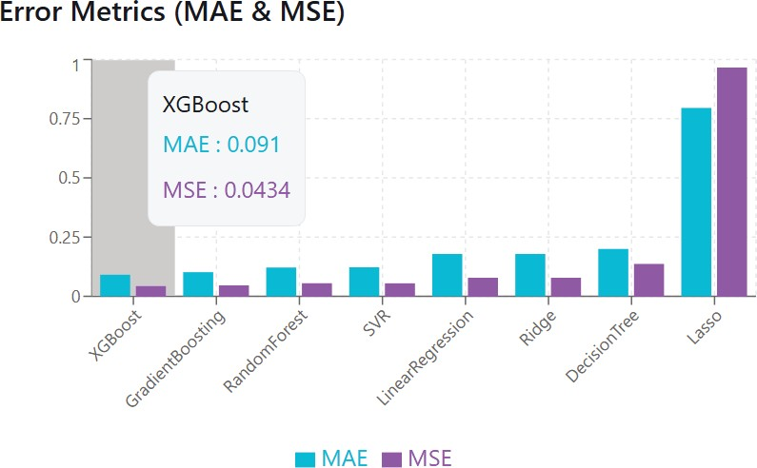

Fig. 1. Error Metrics Comparison

- MAE: 0.0910
- MSE: 0.0434
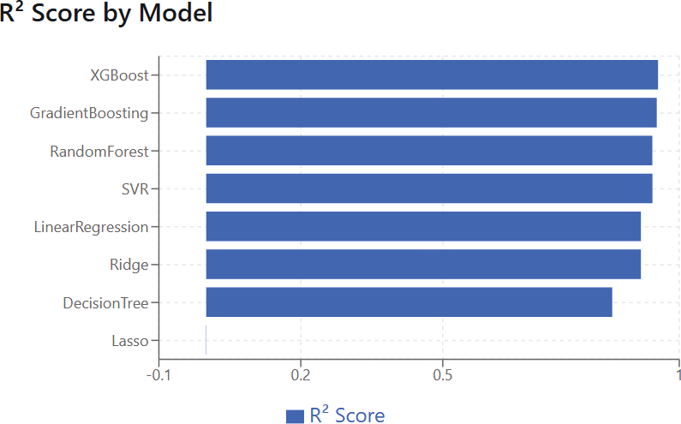

Fig. 2. R2 Scores Comparison

- R² Score: 0.9551
Model | MAE | MSE | R²
XGBoost (Best) | 0.0910 | 0.0434 | 0.9551
Gradient Boosting | 0.1019 | 0.0461 | 0.9523
Random Forest | 0.1213 | 0.0551 | 0.9430
SVR | 0.1224 | 0.0548 | 0.9432
Linear Regression | 0.1789 | 0.0783 | 0.9189
Ridge | 0.1788 | 0.0783 | 0.9189
Decision Tree | 0.2002 | 0.1369 | 0.8582
Lasso | 0.7952 | 0.9660 | -0.0006

The high value of R² indicates modelling to non linear financial relationships helps in improving predictive accuracy and robustness. Therefore, XGBoost was selected as the final deployed regression model.
  - Risk Band Classification Layer
The predicted credit score is categorized in different discrete risk values which are standards defined by RBI. This categorization of score in different risk values helps in decision making:
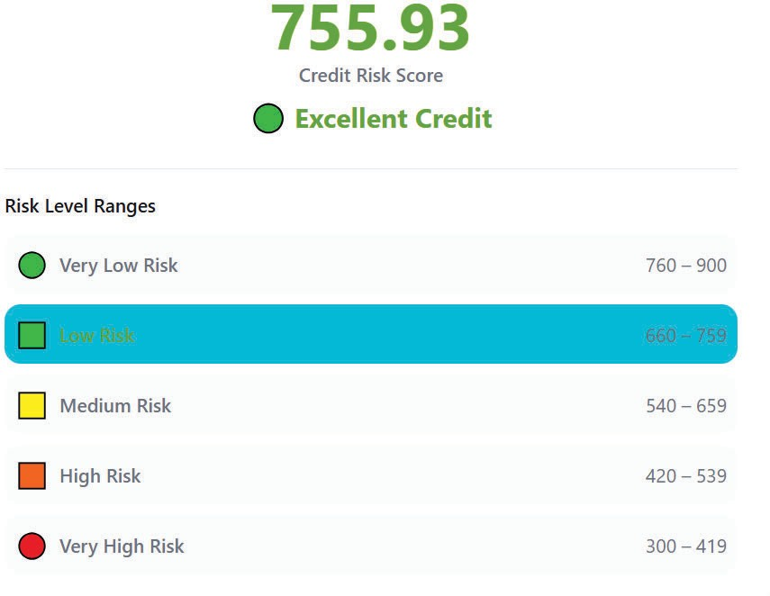
Fig. 3. Discrete Risk Bands

    - ≥ 760: Excellent Credit
    - 660–759: Good Credit
    - 540–659: Fair Credit
    - 420–539: Poor Credit
    - 300-419: Very Poor Credit

This classification helps in automating loan approval, conditional approval, or rejection decisions.
  - Explainability Framework
The system integrates two explainability mechanisms in order to enhance transparency and regulatory compliance:
    - Feature Importance Analysis: Tree-based feature importance values from the XGBoost model are used to estimate feature contribution magnitude.

    - LIME (Local Interpretable Model-Agnostic Explanations): These models are used to explain the prediction and describe the important features contributing in decision making.

Additionally, human-readable explanations are generated for loan rejection or conditional approval cases.
  - Fairness Assessment Methodology


TABLE III. FAIRNESS ASSESSMENT BY AGE GROUPS

Group | Approval Rate | Avg Risk Score | AUC | FPR
Age: 20-30 | 68.0% | 72/100 | 0.880 | 12.0%
Age: 31-40 | 74.0% | 76/100 | 0.890 | 11.0%
Age: 41-50 | 78.0% | 78/100 | 0.900 | 10.0%
Age: 51+ | 76.0% | 77/100 | 0.880 | 11.0%

Model fairness was evaluated across demographic age groups using:
    - Approval Rate
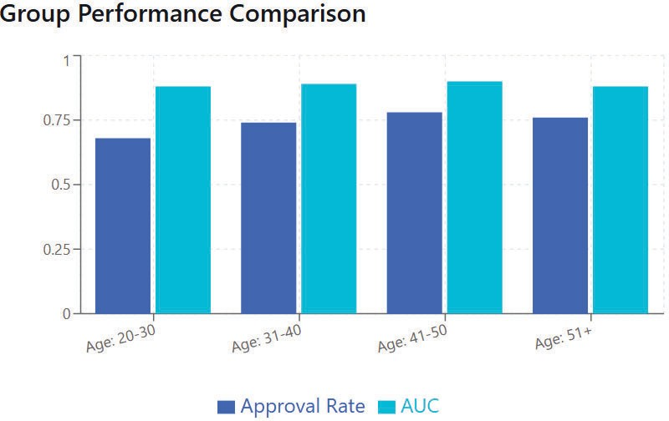

Fig. 4. Groupwise Performance Comparison

    - Area Under ROC Curve (AUC)

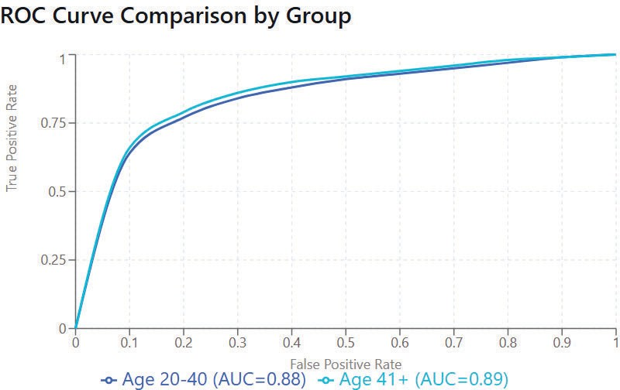

Fig. 5. Group Wise AUC Comparison

- False Positive Rate (FPR)
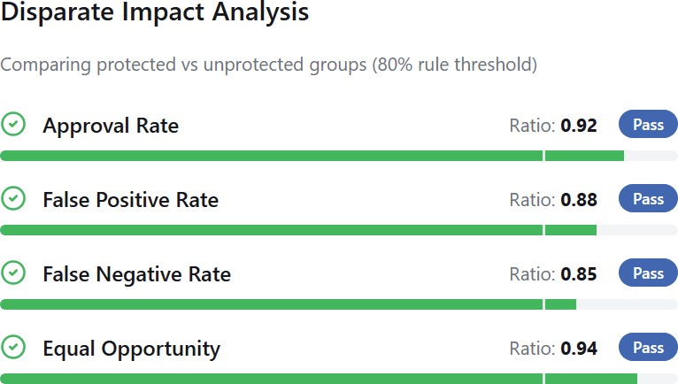

Fig. 6. Disparate Impact Analysis

The system applies the 80% different Impact Rule, ensuring that approval ratios across protected groups remain above the 0.80 threshold, indicating no statistically significant bias.
Equal opportunity difference metrics were also considered to assess fairness consistency.
  - PROPOSED SYSTEM
- System Overview
The proposed system, CREMILL, is a web-based AI-powered credit risk assessment platform integrating machine learning, explainability, and fairness evaluation into a combined decision-support framework.
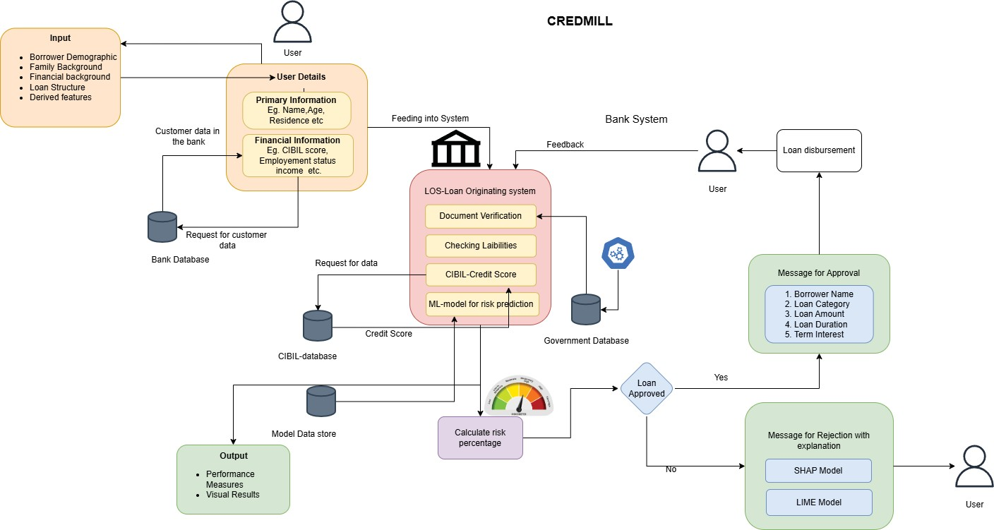
Fig. 7. Architecture Diagram

The system architecture consists of:
  - User Interface Layer: The User interact with the System

  - Data Integration Module: Data is collected from the inputs of the user during form filling.

    - Machine Learning Prediction Engine: The Machine Learning model predicts the score on the basis of input data.

    - Risk Decision Layer: It has different discrete risk values ranging between 300-900 as standard by RBI.

    - Explainability Module: Explainable AI helps to interpret and understand the result of the system in human understandable language.

    - Fairness Monitoring Module: This module helps to mitigate biases

    - Loan Repayment Simulation Module: It manages the repayment of the loan amount

- Operational Flow
The operational flow of the system follows the block diagram:
  - Landing page of the system

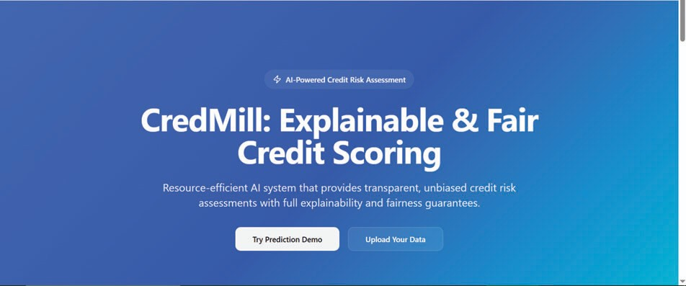

  - The user submits demographic and financial details.
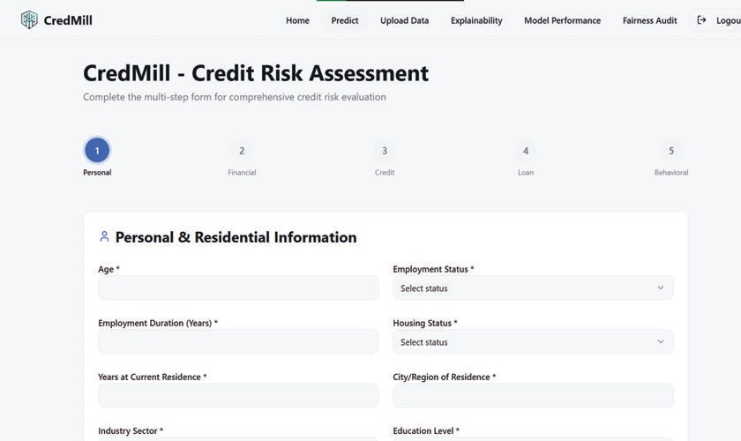

Fig. 8. Five-Sectioned Details Form

  - Data undergoes verification and preprocessing.
  - Features are extracted and encoded.
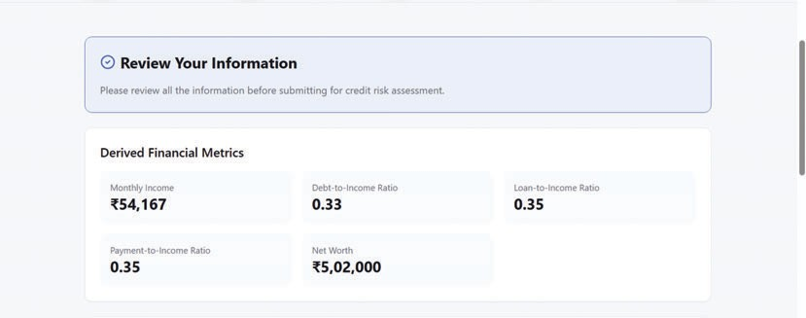

Fig. 9. Error Metrics Comparison
- The fig. 10 shows the prediction of trained XGBoost mode.
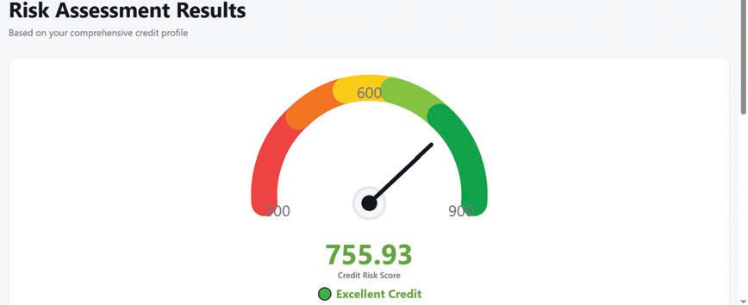

Fig. 10. Risk Meter and Score

- The output score is mapped with the predefined decision category.

- Based on the decision the loan is approved or rejected.
- Performance of the model is stored .

- Prediction Engine
The System is deployed using a Flask-based REST API and hosted on a cloud platform. The trained model is stored using joblib and loaded dynamically at runtime.
Endpoints include:
  - /predict – Returns predicted credit score and risk category.

  - /explain – Returns prediction along with feature importance and LIME explanations.

The model gives the credit score as an output which lies in the range of 300–900 which is a standard defined by RBI and used by various credit scoring systems.
- Loan Decision Logic
Based on predicted credit score:
  - The interest rate and the installment payments are calculated for the Approved loans.Conditional approvals require additional review.

  - Rejected Loans received proper explanation summary about rejection and suggestion to improve the score.

The decision logic improves interpretability and reflects real-world lending frameworks.
- Loan Repayment and Dynamic Score Update
The system includes a loan repayment simulation module where:
  - Timely payments positively influence credit score.
  - Delays and defaults reduce credit score.
  - Penalties and recovery processes are visualized.

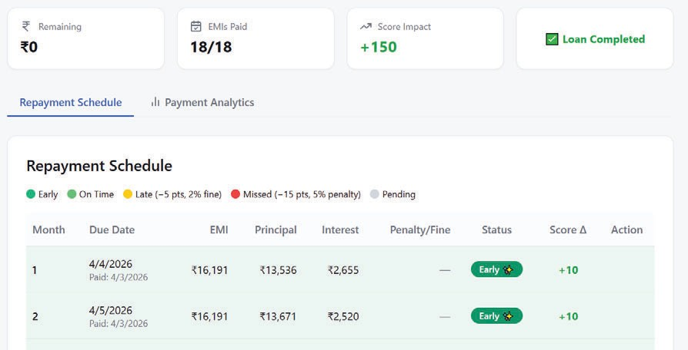

Fig. 11. Five-Sectioned Details Form

This dynamic adjustment mechanism models long-term borrower behavior impact.
- Explainability Module
The explainability module generates:
  - Global feature importance ranking

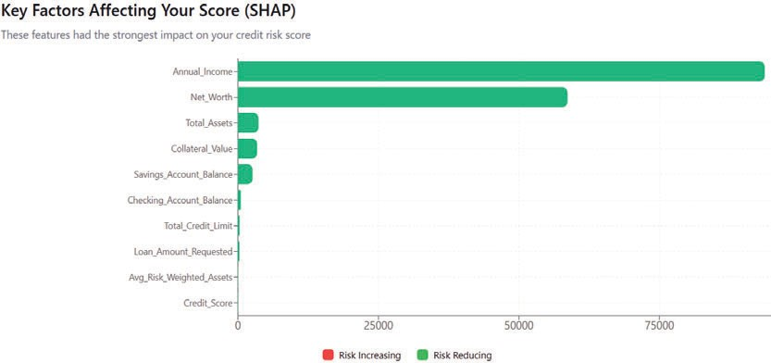

Fig. 12. SHAP Analysis

  - Local LIME explanations

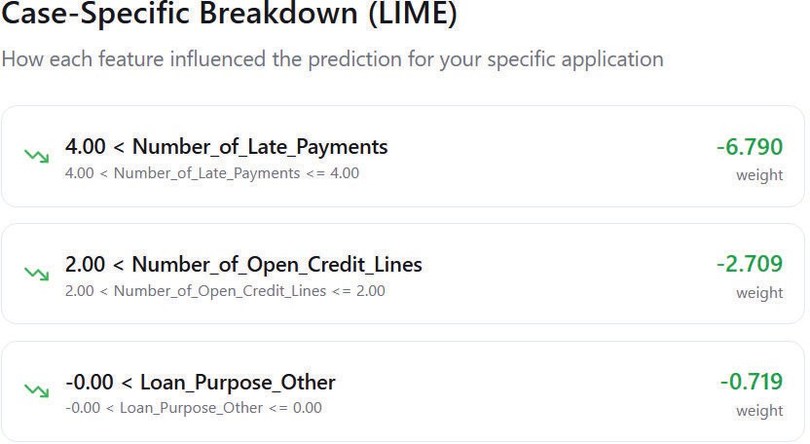

Fig. 13. LIME Analysis

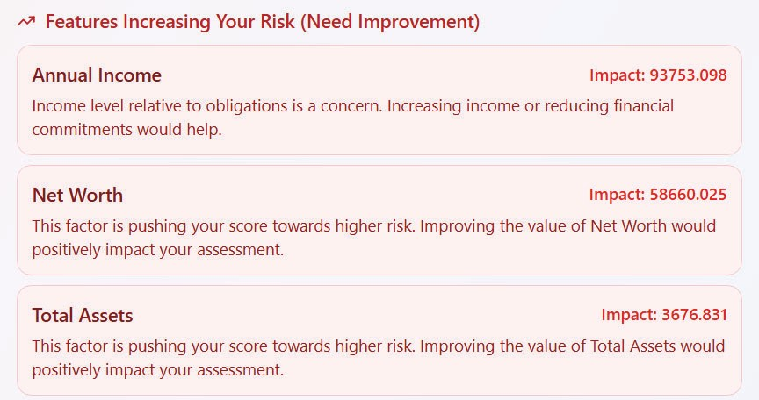
  - Human-readable rejection reasons
  - Approval strength indicators



Fig. 15. Key Strength Indicators

This increases trustworthiness and supports ethical AI deployment in financial systems.
- Fairness Monitoring
A dedicated fairness dashboard evaluates:
  - Age-based approval distribution
  - Performance metrics across demographic groups
  - Compliance with 80% rule
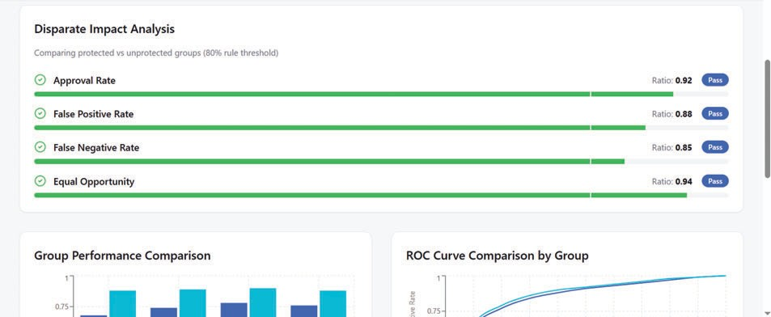

Fig. 16. Fairness Dashboard

This ensures transparency and mitigation of algorithmic bias.
- Frontend Architecture
The frontend is developed using:
  - React (Vite framework)
  - TypeScript
  - Tailwind CSS

  - ShadCN UI components

Fig. 14. Feature Importance in Result

It provides:

Fig. 17. Landing Page

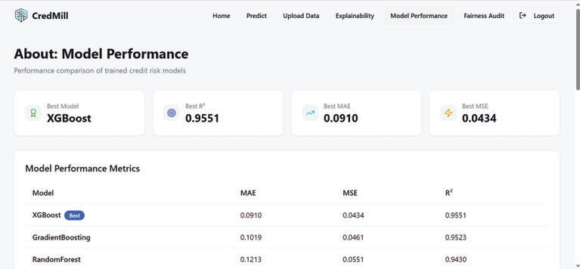
    - Model evaluation dashboard
The experimental results show that ML models can achieve high prediction accuracy while remaining scalable and efficient. The study also highlights the importance of transparency, ethical considerations, and continuous model monitoring for deploying such systems in financial environments.

Fig. 18. Model Performance Dashboard

    - Prediction form (multi-section)
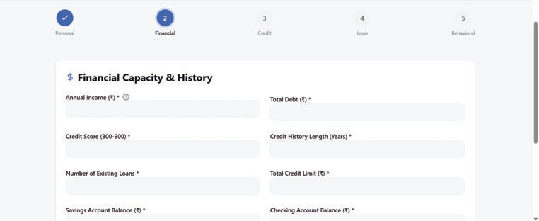

Fig. 19. Section Two of the Form

    - Explainability visualization
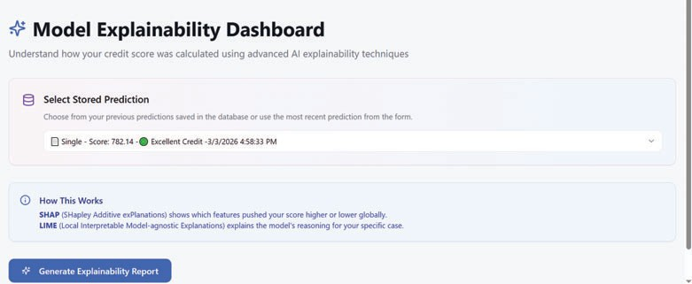

Fig. 20. Explanability Dashboard

    - Fairness metrics display
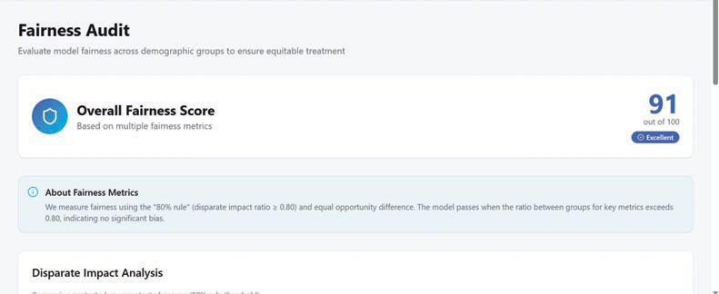

Fig. 21. Fairness Page

  - CONCLUSION
This research presents an AI-based Credit Risk Assessment System aimed to enhance predictive accuracy, interpretability, and real-world usability in financial institutions. Making use of existing advancement in machine learning-driven credit scoring [2], [10], the system uses a supervised learning model technique which is trained on structured borrower data with engineered features to predict the credit risk score more reliably.
Unlike earlier studies that focus mainly on fairness metrics [1] or interpretability mechanisms [8], [14], the proposed system integrates the complete pipeline which includes data preprocessing, feature engineering, model training, evaluation, and web-based deployment into a combined pipeline. These systematic approaches make the system more practical and can be used in the real world by any financial institute leveraging the power of AI/ML.
  - FUTURE WORK
The proposed system gives good and desired results by making use of ML and explainable AI with high accuracy human interpretable results the system can be improved further to ensure scalability, reliability and making it more user friendly.
Further, to reduce the algorithmic bias across various features the steps can be taken to optimize the fairness-aware model. Using advanced deep learning architectures such as Transformers and hybrid ensemble frameworks [13], [16] helps improve performance on large-scale and understand the pattern in sequential financial datasets.
Also, adding advanced Explainable AI dashboards advised in [8], [15]can help users better understand the model and increase trust. Another improvement can be done to analyze financial text using language-model-based approaches similar to LLM-driven systems [9], [17].
Finally, the system can be further improved by adding real-time adaptive learning and automatic model training. This will help to adapt dynamic market conditions and concept drift more effectively[2], [10].
ACKNOWLEDGMENT
The research team would like to thank Dr. Nupur Giri, Head of the Computer Engineering Department and Dr. Gresha Bhatia, Deputy Head of the Computer Engineering Department at VESIT (Autonomous), for their constant guidance, support, and mentorship throughout this project. Their suggestions, encouragement, and thoughtful feedback helped us to improve the work at every stage and lead to final success. The team also would like to thank the Computer Engineering Department at VESIT (Autonomous) for giving the necessary resources and environment to complete this project. Additionally, the team is grateful to all those who have contributed, directly or indirectly, to the successful realization of this research. Their support and collaboration have greatly enriched its outcome.

REFERENCES
- N. Kozodoi, J. Jacob, and S. Lessmann, "Fairness in credit scoring: Assessment, implementation and profit implications," European Journal of Operational Research, vol. 297, no. 3, pp. 1083–1094, 2022.

- S. Shi, R. Tse, W. Luo, S. D’Addona, and G. Pau, "Machine learning-driven credit risk: a systemic review," Neural Computing and Applications, vol. 34, pp. 14327–14339, 2022.

- P. Malik, A. Anand, A. K. Baliyan, A. Dongre, and P. Panwar, "Credit Risk Assessment and Fraud Detection in Financial Transactions Using Machine Learning," International Journal of Scientific Research & Engineering Trends, vol. 10, no. 2, pp. 433–440, 2024.

- G. Nwachukwu, "Enhancing Credit Risk Management Through Revalidation and Accuracy in Financial Data: The Impact of Credit History Assessment on Procedural Financing," International Journal of Research Publication and Reviews, vol. 5, no. 11, pp. 631–644, 2024.

- T. E. Edunjobi and O. A. Odejide, "Theoretical frameworks in AI for credit risk assessment: Towards banking efficiency and accuracy," International Journal of Scientific Research Updates, vol. 7, no. 1, pp. 92–102, 2024.

- P. Pal, Z. Wang, X. Zhu, J. Chew, K. Pruś, and X. Wei, "AI-Based Credit Risk Assessment and Intelligent Matching Mechanism in Supply Chain Finance," Journal of Theory and Practice in Economics and Management, vol. 2, no. 3, pp. 1–9, 2025.

- M. R. Machado, D. T. Chen, and J. R. Osterrieder, "An analytical approach to credit risk assessment using machine learning models," Decision Analytics Journal, vol. 16, 100605, 2025.

- A. Mujo, S. Nikolla, E. Hoxha, and E. Pelivani, "Explainable AI in Credit Scoring: Improving Transparency in Loan Decisions," Journal of Information Systems Engineering and Management, vol. 10, 2025.

- M. Golec and M. AlabdulJalil, "Interpretable LLMs for Credit Risk: A Systematic Review and Taxonomy," Manuscript under review (Preprint), 2025.

- J. K. Roy and L. Vasa, "Transforming credit risk assessment: A systematic review of AI and machine learning applications," Journal of Infrastructure, Policy and Development, vol. 9, no. 1, 9652, 2025.

- A. R. Dil, "AI and Machine Learning in Credit Risk Assessment," Independent Paper / Whitepaper, 2025.

- V. R. Duvalla, "AI-Powered Credit Risk Assessment: Transforming Lending in FinTech," European Journal of Computer Science and Information Technology, vol. 13, no. 23, pp. 115–131, 2025.

- E. Siphuma and T. Van Zyl, "Enhancing Credit Risk Assessment through Transformer-Based Machine Learning Models," Independent Paper / Preprint, 2025.

- D. O. Oyeyemi, O. O. Okosieme, O. Idowu-Kunlere, E. A. Julius, and I.
P. Nwinyi, "Explainable AI For Credit Risk Assessment: Integrating Machine Learning With Business Analytics," IOSR Journal Of Economics and Finance, vol. 16, no. 5, pp. 63–72, 2025.

- Shreya and H. Pathak, "Explainable Artificial Intelligence Credit Risk Assessment using Machine Learning," SRM University (Preprint), 2025.

- B. D. Taiwo, "Deep Learning Architectures for Credit Risk Assessment," Research Square, 2026.

- K. Shamsi, D. Novokmet, J. Peters, M. L. Liu, P. K. Edwards, and V. Khoshdel, "LendNova: Towards Automated Credit Risk Assessment with Language Models," in AAAI 2026 Workshop on Agentic AI in Financial Services, 2026.

Designing an Al-Based Credit Risk Assessment System for Predictive Financial Analytics

by Gaurav Gupta

Submission date : 13-Apr-2026 09:47AM (UTC+0530)
Submission ID: 2930161090
File name : CredMill_-_Draft_-_Research_paper.pdf (1.57M)
Word count: 4981
Character count: 29644

Designing an Al-Based Credit Risk Assessment System for Predictive Financial Analytics




ORI GINALITY REPORT

SIMILARITY INDEX
INTERNET SOURCES
PUBLICATIONS
STUDENT PAPERS

PRIMARY SOURCES

journalijsra.com
Internet Source

Submitted to
Student Paper

eajournals.org
Internet Source

woodyinternational.com
Internet Source

autodocbox.com
Internet Source

eprints.umsida.ac.id
Internet Source

indiraicem.ac.in
Internet Source

www .sngimr.in
Internet Source

Submitted to Liverpool John Moores University
Student Paper

journalwjarr.com
Internet Source

www.ijfmr.com
Internet Source

oeconomia.pl
Internet Source

www .sci rp.org

Internet Source

systems.en press-publisher.com
Internet Source

Exclude quotes On Exclude matches < 1%
Exclude bibliography On

Inhouse/ Industry _Innovation/Research :
SustainableGoa] : i . .Deuvit WO"(),( a.nJ flconol'ni'c L-,tt,.,.

Title of Project: .C. _drni \1

Project Evaluation She et 2025 - 26
Q sk . A-s£.eSsB'o •
C lass: D17 k/Ja/

Group No.: ·S"

G roup Members: S ae¢JQ#o.1;.,Tan1w"10...¾'""'4i) t\emo<J-g_ot-avn cm /561 _{""LLU.J,,LU\/} V p L,V- '--·- '. / _{-v} / .


I Resear-I T o ta l
ch Marks
Paper

I (5) I (50)

Comments: P,,,z.,--- ro...';\--_d [AJ.,d.;;.v-

+.. 1--

.rJ . hlo.t-<. t
1 03 I Lf
v•0,-,_ k.._
Engineering  Concepts & Know le dge |  | Interpretation  of Problem & Analysis | Design/  Prototype | Interpretation of Data& Dataset | Modern Tool Usage | Societal Benefit, Safety  Cons ideration | Environ men! Friendly | Ethics | Team work | Presentati on Skills | App lied Engg&M gmt principles | Life - long learning | Profess iona l Skills | 1 Jnnov alive  Appr oach
(5) |  | (5) | (5) | (3) | (5) | (2) | (2) | (2) | (2) | (2) | (3) | (3) | (3) | (3)
Dl..r | I | b y | D y | DJ;> | 0 | 02- | 02.. | 02- | 0 ).._..... | 02,_. | o2. | 0 | o_ | O_J

Name & Signa ture viewer I

Engineering Concepts & Knowledge  (5) | Interpretation of Problem & Analys is  (5) | Design/ Prototype  (5) | Interpretation of Data & Dataset  (3) | Modern Tool Usage  (5) | Societal Benefit, Safety Consideration  (2) | Environ ment Frie ndly  (2) | Ethics  (2) | Team work  (2) | Presentati on Skills  (2) | Applied Engg&M gmt principles  (3) | Life- long learning  (3) | Profess ional Skills  (3) | lnnov ativc Appr oath  (3) | Rcscar  -ch Paper  (5) | Total Marks  (50)
01...,, | 0 | O L.i | 03 | 0 | 02- | () 2- | 01... | 02- | 0 2 | 02.... | Q; | 0-2> | OJ | b 3>
Comments :._ _ _ _ _ _ _ _ _ _ _ _ _ _ _ _ _ _ _ _ _ _ _ _ _ _ _ _ _ _ _ _ _ _ _ _ _ _ _ _ _ _ _ _ _ _ _ _

? '{1)\ 0-k Je,, J_
Date: 7th February, 2026 Nam Signa tureL 'Reviewer 2

lnho1s Indus! '_]nnoration/Re search:
Class: D177t:/-WC

Group No.: 5
Sustainable Goal: 8 ' _{'i)e_te.'"'-t} _{"'-)} O'<'\:- t c,-..orn; e (:,-.-e:,....:) Project Evaluation Sheet 2025 - 26
Title of Project: C'( e o Mi\ I
- f:\'I"' A I.
A $E:SS 0'.':C
Sc,.\-"""' t-\o .,_L. Po._ \
r-. o.., , ..,..,. ,
-
G,.-, . i...,..
tl\,c. - c;o
t:,\""I C. - ::i.'
0-1, c.... - L.t 9-" - ...
Q\ . v •- · - - ...,-o • • ......,n Cl'°'\,-.."'{"O"'
Group Members: _{\.-\Q_} _{T"\-\-}
\, C-H
Enginee rin g Concepts & Knowledge  (5) | In te rpretat io n of Problem & Ana lysis  (5) | Des ign / Prototype  (5) | I nte rpreta ti o n of Data & Dataset  (3) | Modem Tool Usage  (5) | Societa l Benefit, Safety Conside ration  (2) | Environ ment Frie ndly  (2) | Ethics  (2) | Team work  (2) | Presenta ti on Skills  (2) | App lied Engg&M gmt principles  (3) | Life - long learning  (3) | Profe ss ional Skills  (3) | Innov ative Appr oach  (3) | Resear-  ch  Paper  (5) | Total Ma rks  (50)
0 | D | Oy | O:;> | t)y | 02-- | 02- | 02.. | 02- | OL | 02:> | 03 | 03, | D2> | -03 | Lr ;
Comments:_ _ _ _ _ _ _ _ _ _ _ _ _ _ _ _ _ _ _ _ _ _ _ _ _ _ _ _ _ _ _ _ _ _ _ _ _ _ _ _ _ _ _ _ _ • •
'Dr,- r.,,_NL slJ-: ,--­
""Name & Signature Re e l

Engineering Concept s & Knowledge  (5) | Interpretation of Problem & Analysis  (5) | Desig n / Prototype  (5) | Interpreta tio n of Data & Datase t  (3) | Modem Tool Usage  (5) | Societal Benefit, Safety  Cons ideratio n  (2) | Env iron ment Frie ndly  (2) | Eth ics  (2) | Team work  (2) | Presenta ti on Skills  (2) | Applied Engg&M gmt principles  (3) | Life - long learning  (3) | Profes s ional Skills  (3) | lnnov ative Appr oach  (3) | Rese ar  -ch  Paper  (5) | To tal Marks  (50)
D5 | 04 | D | Op | C>½ | 02 | D2- | u:2-- | 02- | Oc.. | D3 | '03> | u_p | tl) | 03 | s
Com me nts:- - - - - - - - - - - - - - - - - - - - - - - - - - - - - - - - - - - - - - - - - - - - - -

Date: 5th March, 2026
<v-/1 0 · S c}-c.-·
Na meA ig nature Reviewo f 2
d

